|  |
| --- |
|  |
| Capstone Project Document |

KARYWELL SYSTEM

Detail Desgin

|  |  |  |
| --- | --- | --- |
| **KaryWell System** | | |
| **Group Members** | Le Van Quy Hoang | SE90184 |
| Tran Dinh Hoang Huy | SE90201 |
| Nguyen Khac Hoang | SE02564 |
| Kieu Cao Khanh | SE02960 |
| Nguyen Van Quyen | SE02884 |
| Nguyen Thi Hong Nhung | SE02437 |
| **Supervisor** | Mr. Tran Binh Duong | |
| **Project code** | KW | |

**- Hanoi, 12/2015 -**

**Table of Contents**

[1. PROJECT INFORMATION 3](#_Toc430547296)

[2. PROJECT TEAM 3](#_Toc430547297)

[3. INITIAL IDEAL 4](#_Toc430547298)

[3.1 Background 4](#_Toc430547299)

[3.2 Literature review 7](#_Toc430547300)

[3.2.1 Free shipper 7](#_Toc430547301)

[3.2.2 Shipper companies 7](#_Toc430547302)

[3.2.3 Overrall disadvantage of current background 12](#_Toc430547303)

[3.3 Our Proposal 14](#_Toc430547304)

[3.3.1 Web application for store 14](#_Toc430547305)

[3.3.2 Mobile application for shipper 15](#_Toc430547306)

[3.3.3 Web application for admin 15](#_Toc430547307)

[3.3.4 Server 15](#_Toc430547308)

[4.4.5 Out of scope 16](#_Toc430547309)

## INTRODUCTION

### Purpose

### Definitions, Acronyms and Abbreviations

## DETAIL DESIGN

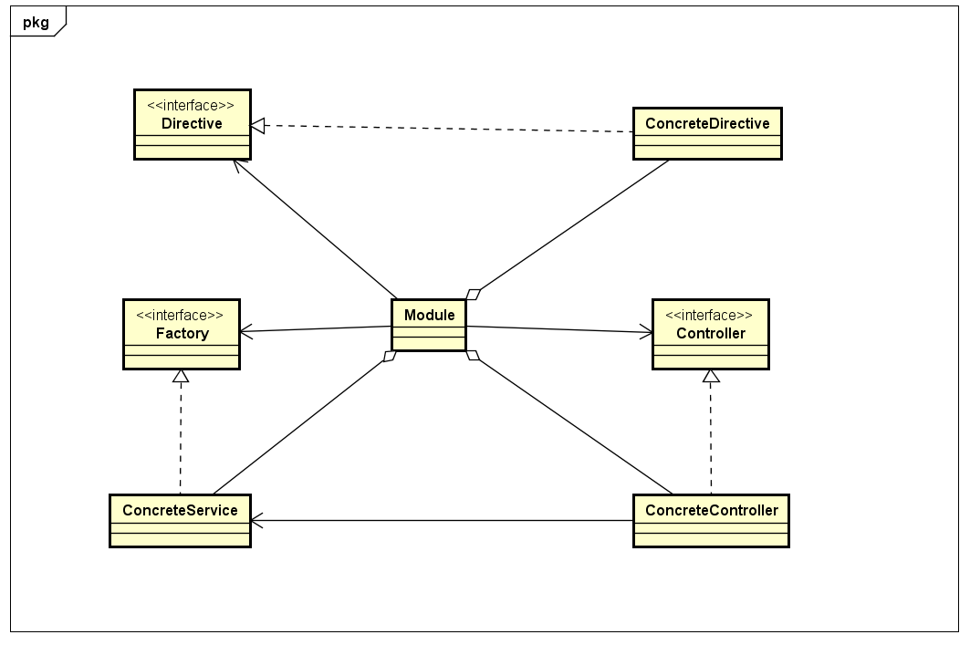

Figure 1 Class Diagram of Angular module

### Mobile Application

#### Login

***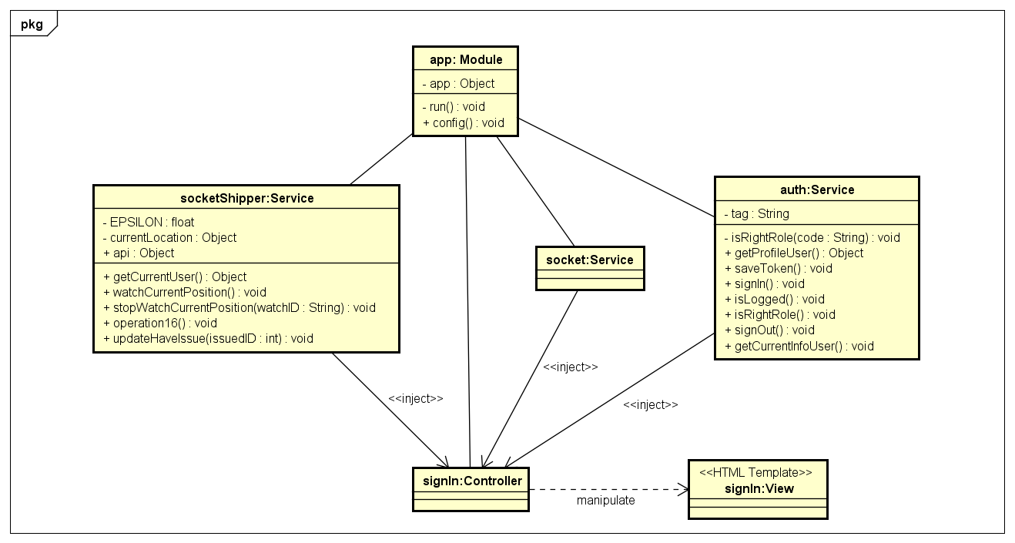***

Figure 2 Object Diagram of Login use case

***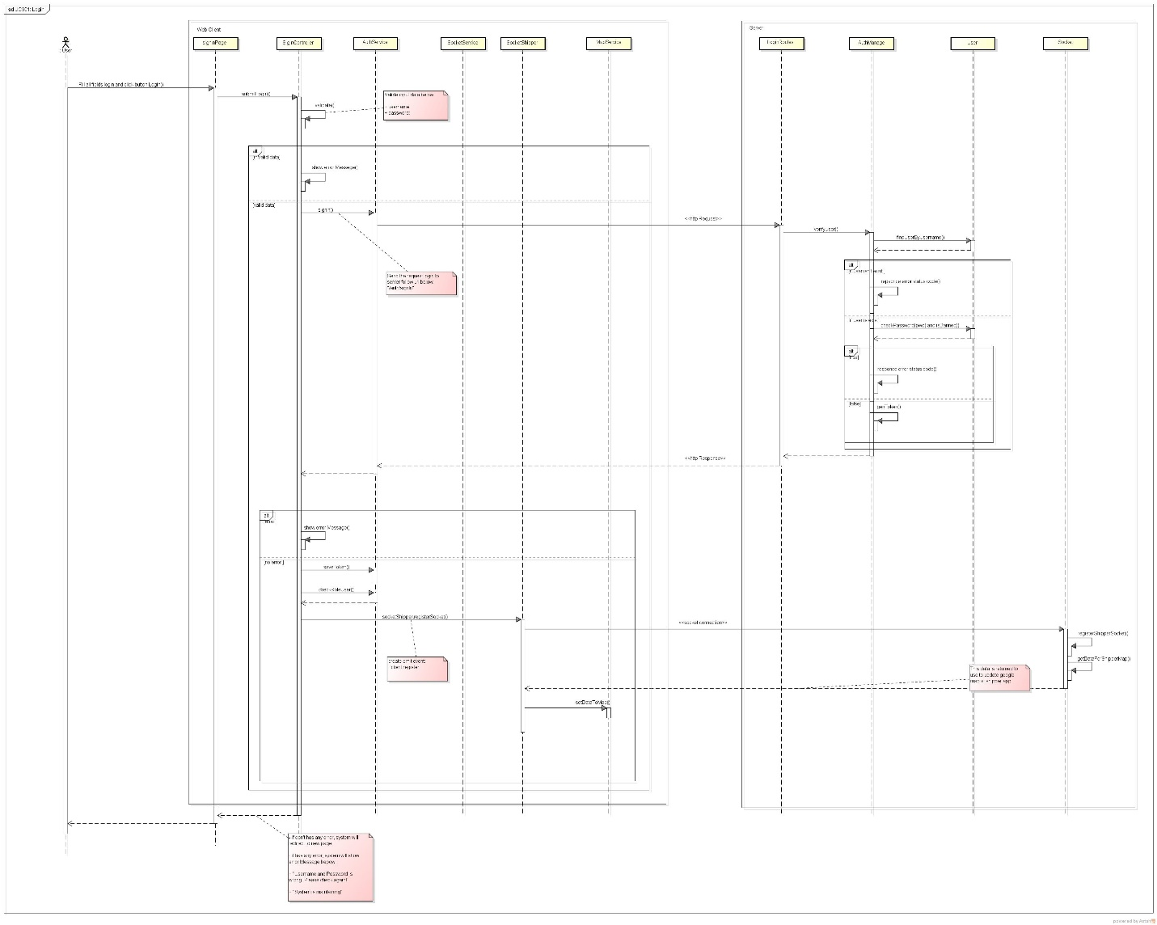***

Figure 3 Sequence Diagram of Login use case

#### View Profile

***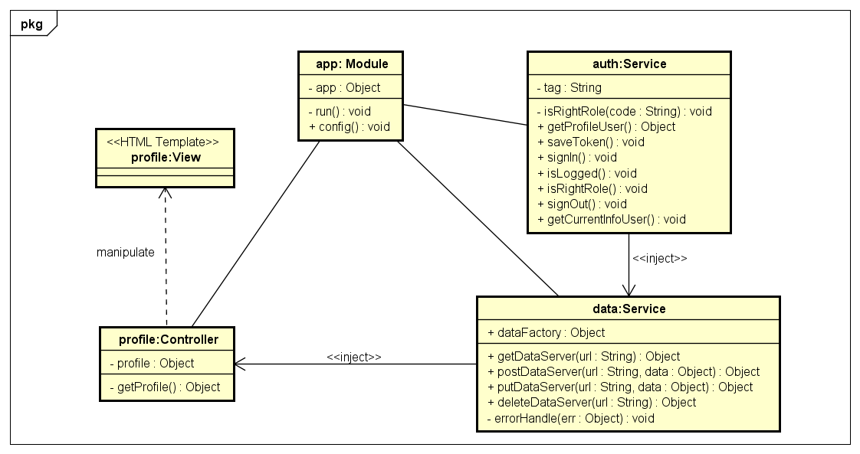***

Figure 4 Object Diagram of View Profile use case

***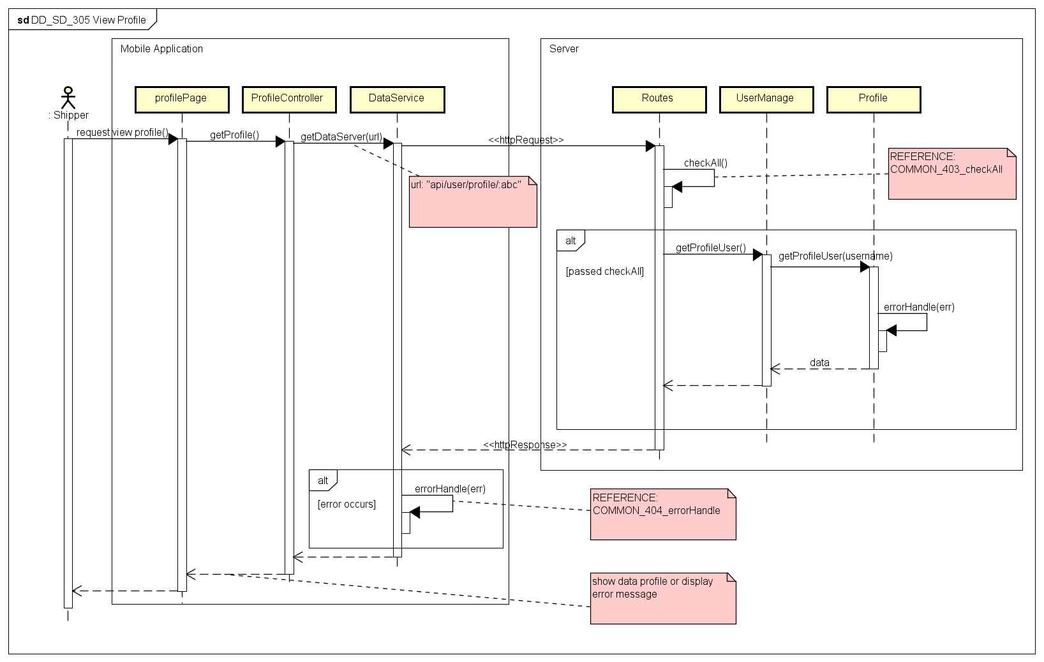***

Figure 5 Sequence Diagram of View Profile use case

#### Confirm Code

***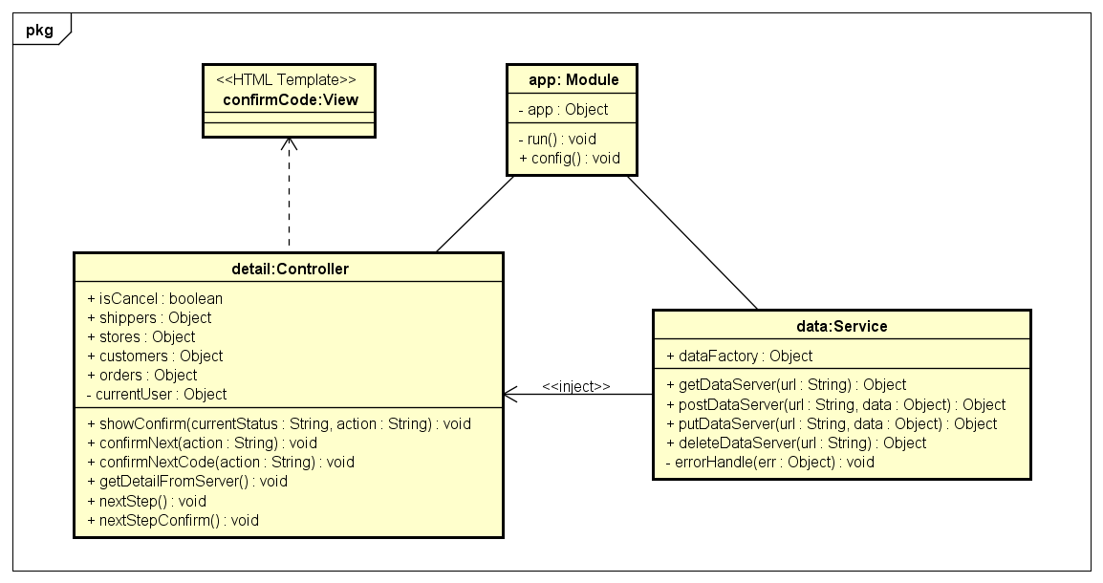***

Figure 6 Object Diagram of Confirm Code use case

***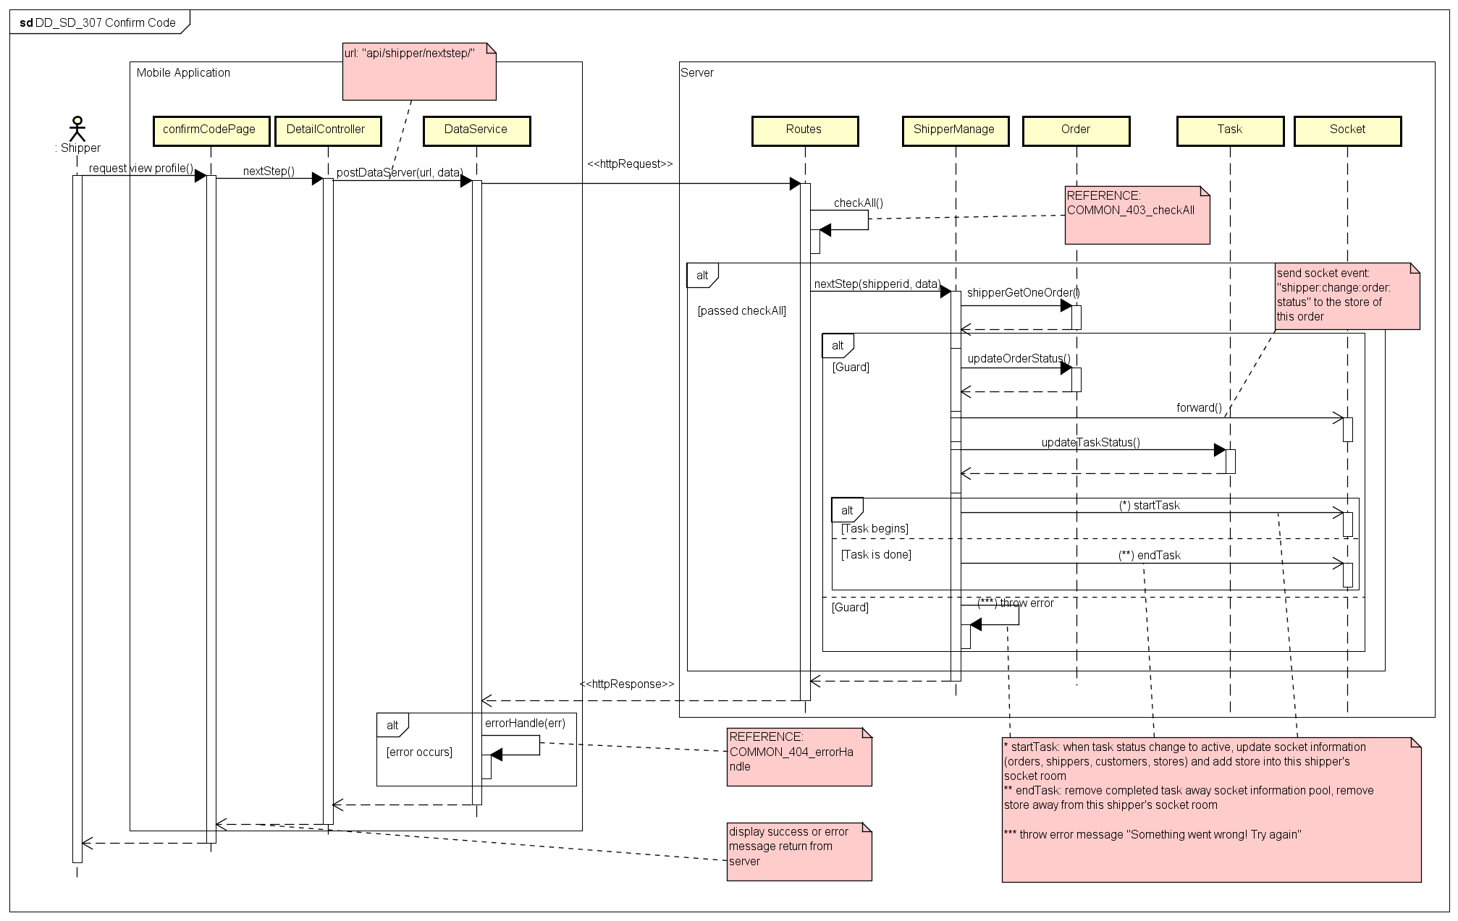***

Figure 7 Sequence Diagram of Confirm Code use case

#### Grab Order

***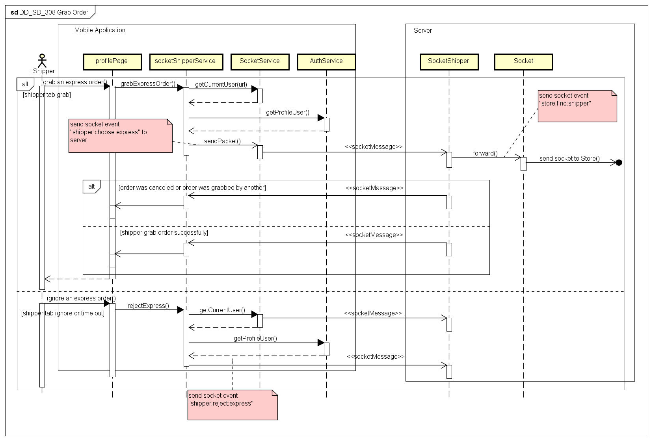***

Figure 8 Object Diagram of Grab Order use case

#### View Task’s List

***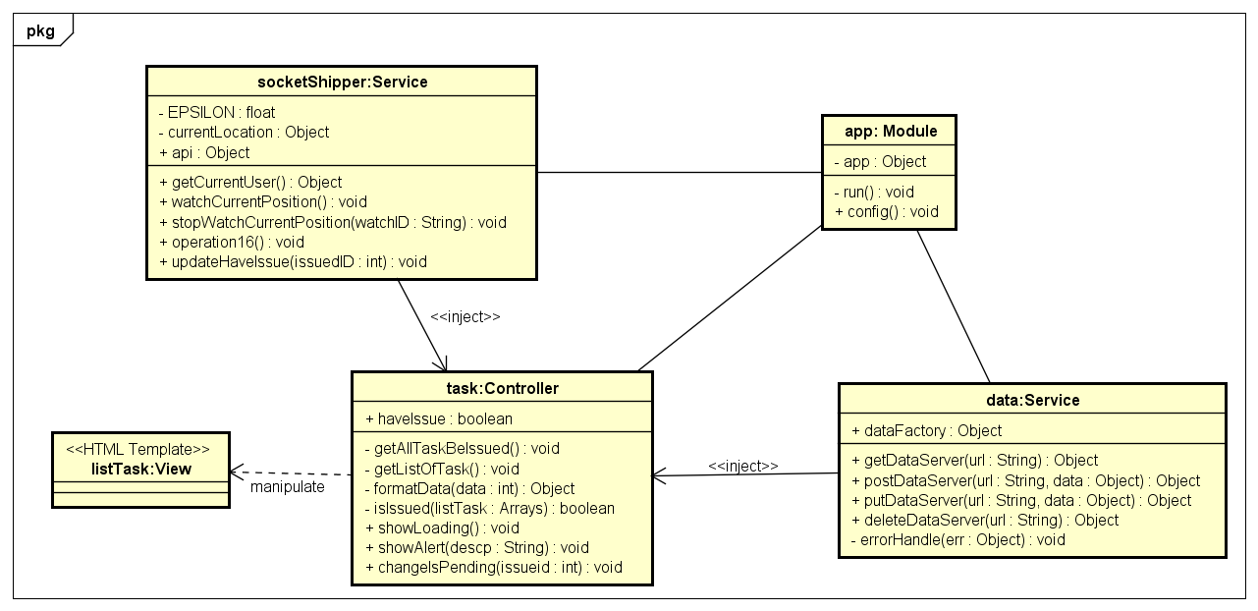***

Figure 9 Object Diagram of View Task’s List use case

***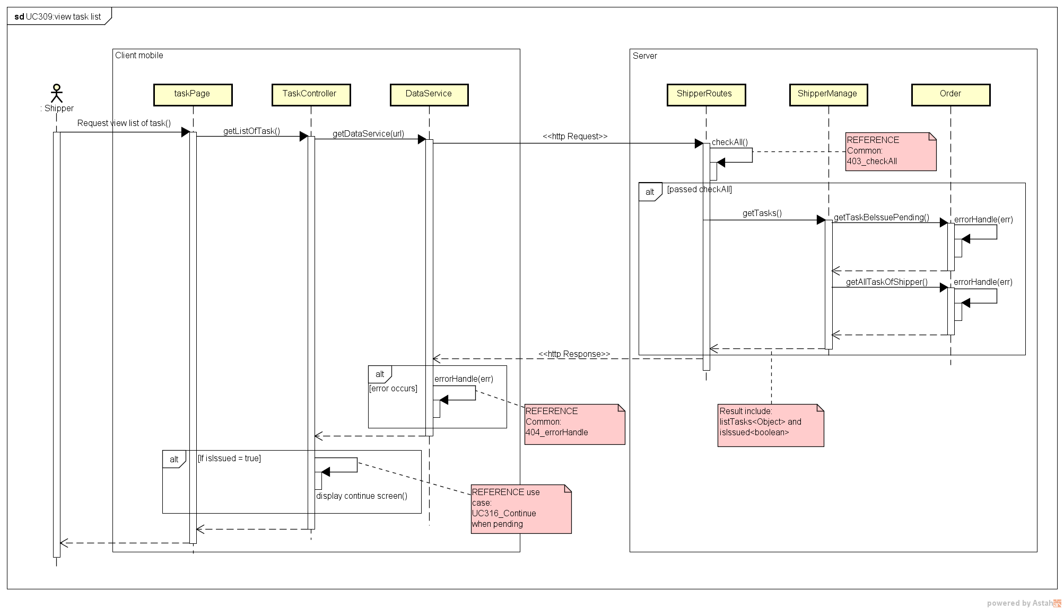***

Figure 10 Sequence Diagram of View Task’s List use case

#### View Task’s Detail

***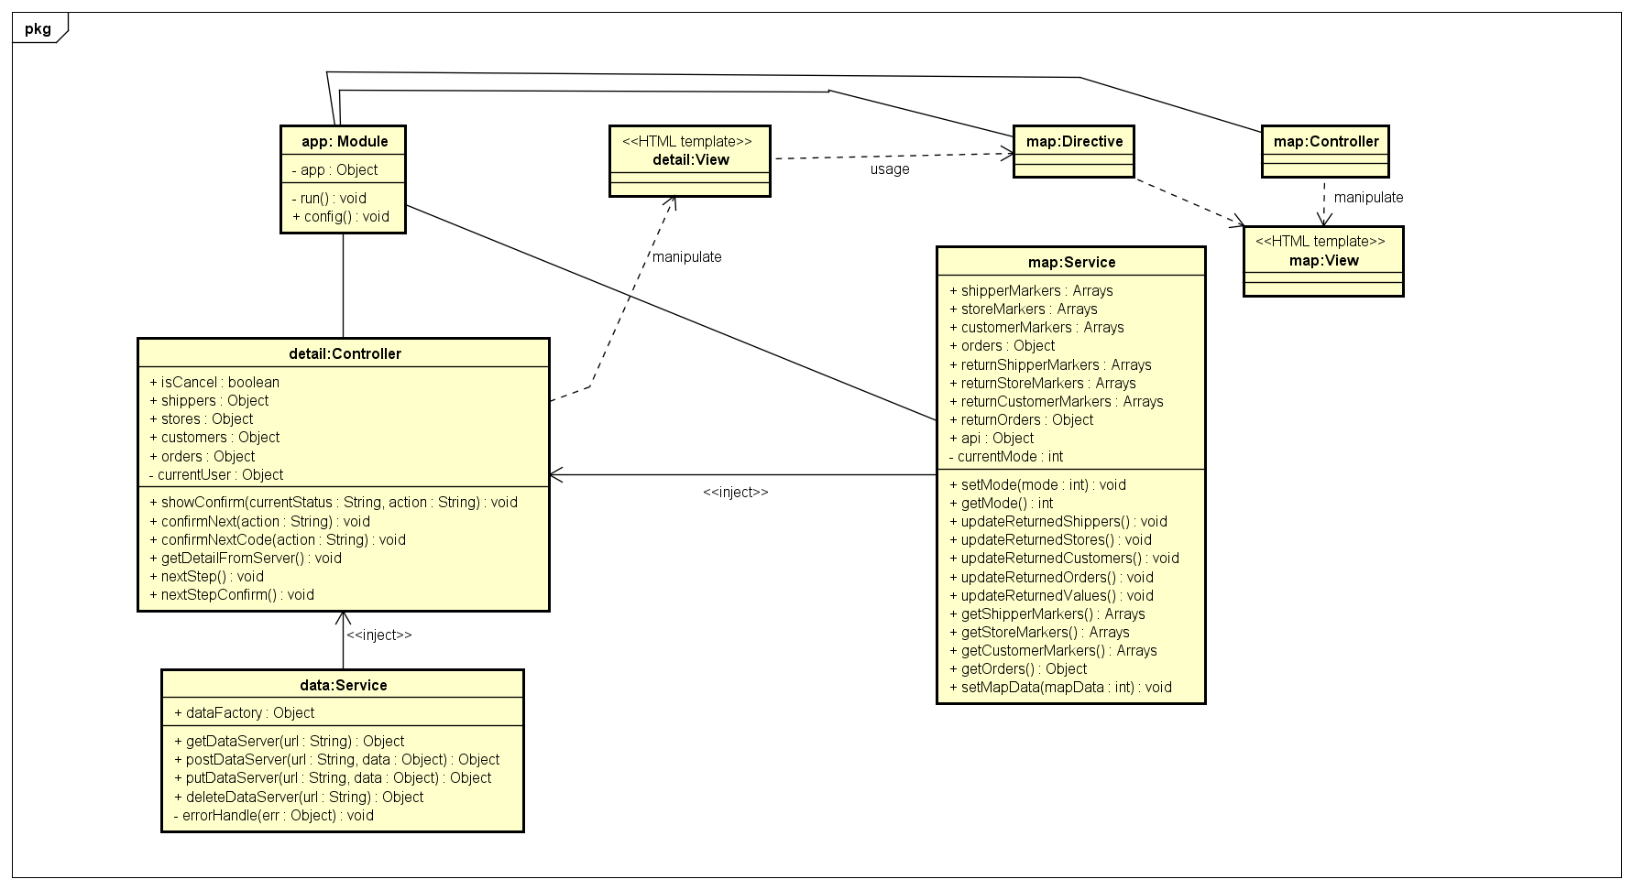***

Figure 11 Object Diagram of View Task’s Detail use case

***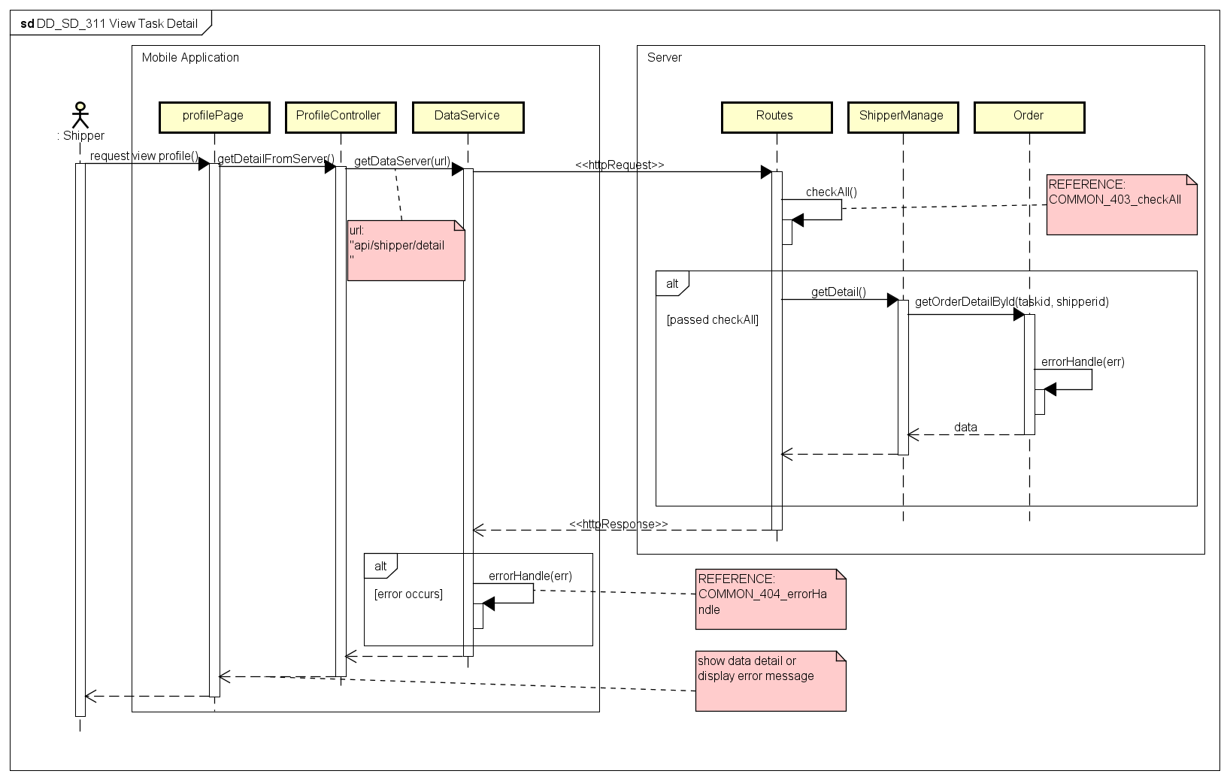***

Figure 12 Sequence Diagram of View Task’s Detail use case

#### Send Issue Information

***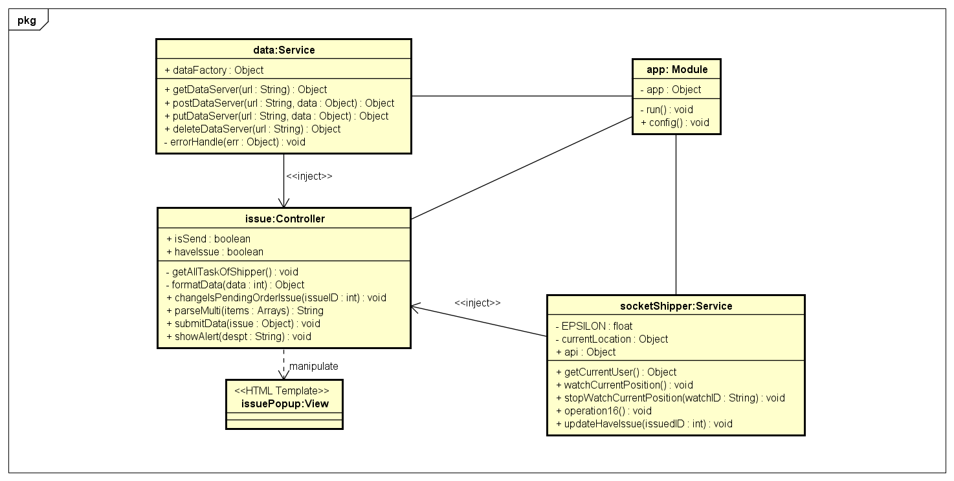***

Figure 13 Object Diagram of Send Issue use case

***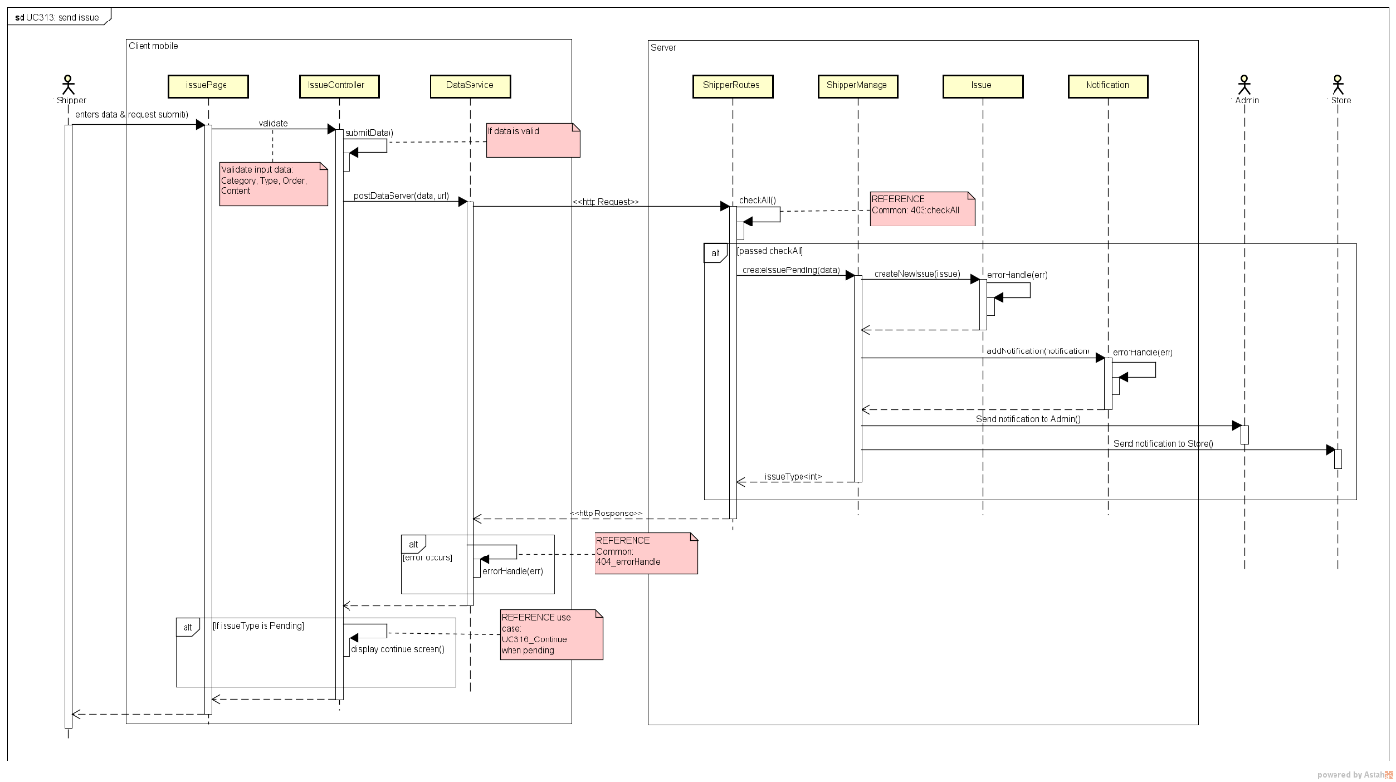***

Figure 14 Sequence Diagram of Send Issue use case

#### Change Working Status

***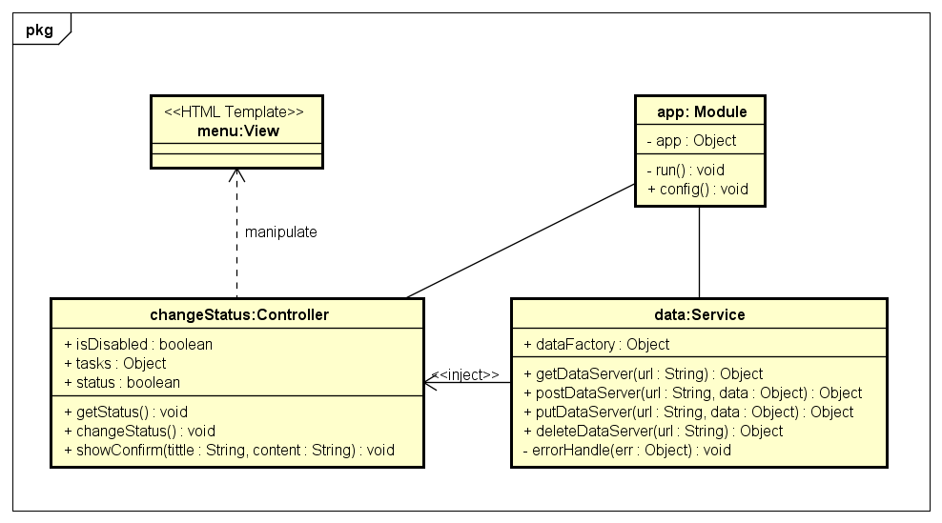***

Figure 15. Object Diagram of Change Working Status use case

***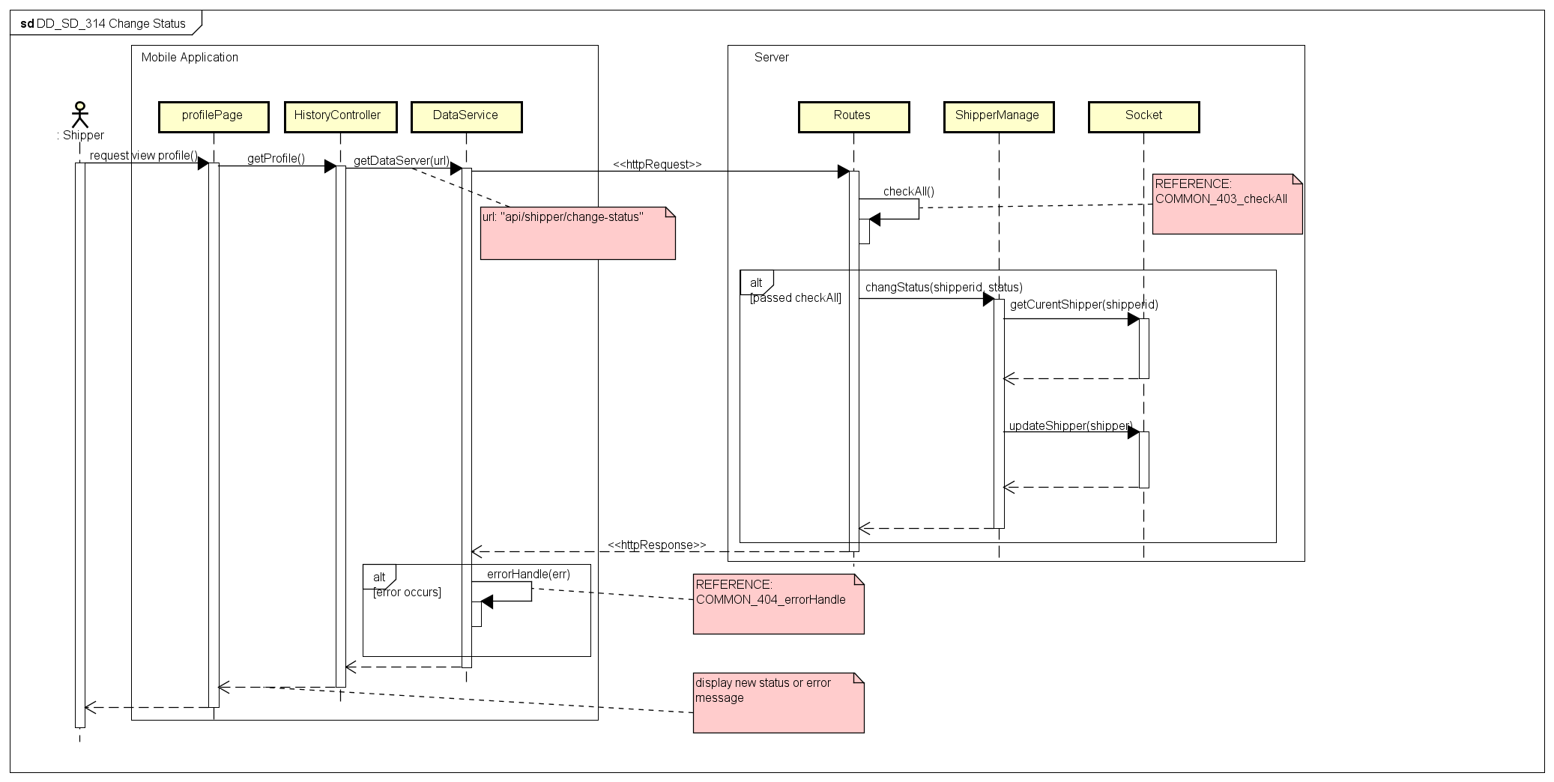***

Figure 16. Sequence Diagram of Change Working Status use case

#### View History

***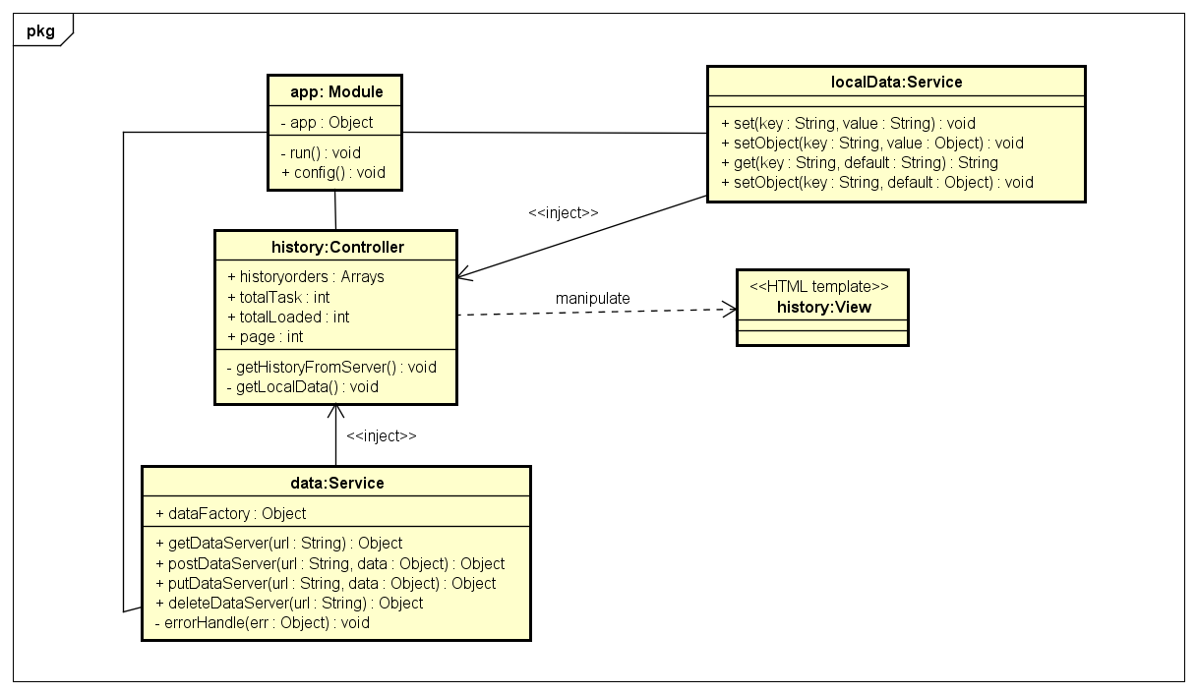***

Figure 17. Object Diagram of View History use case

***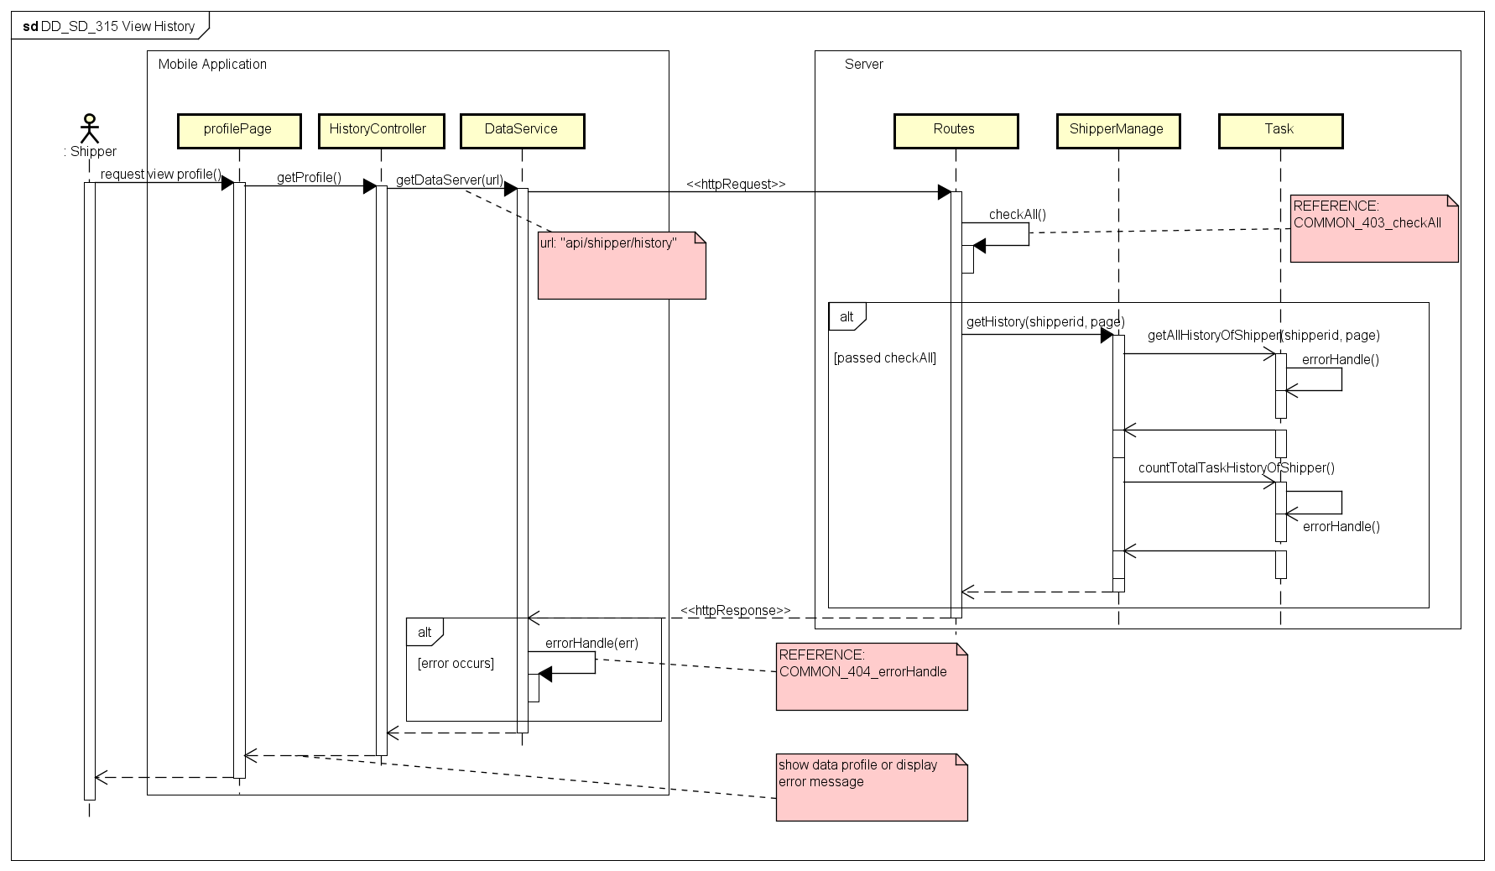***

Figure 18. Sequence Diagram of View History use case

#### Continue When Pending

***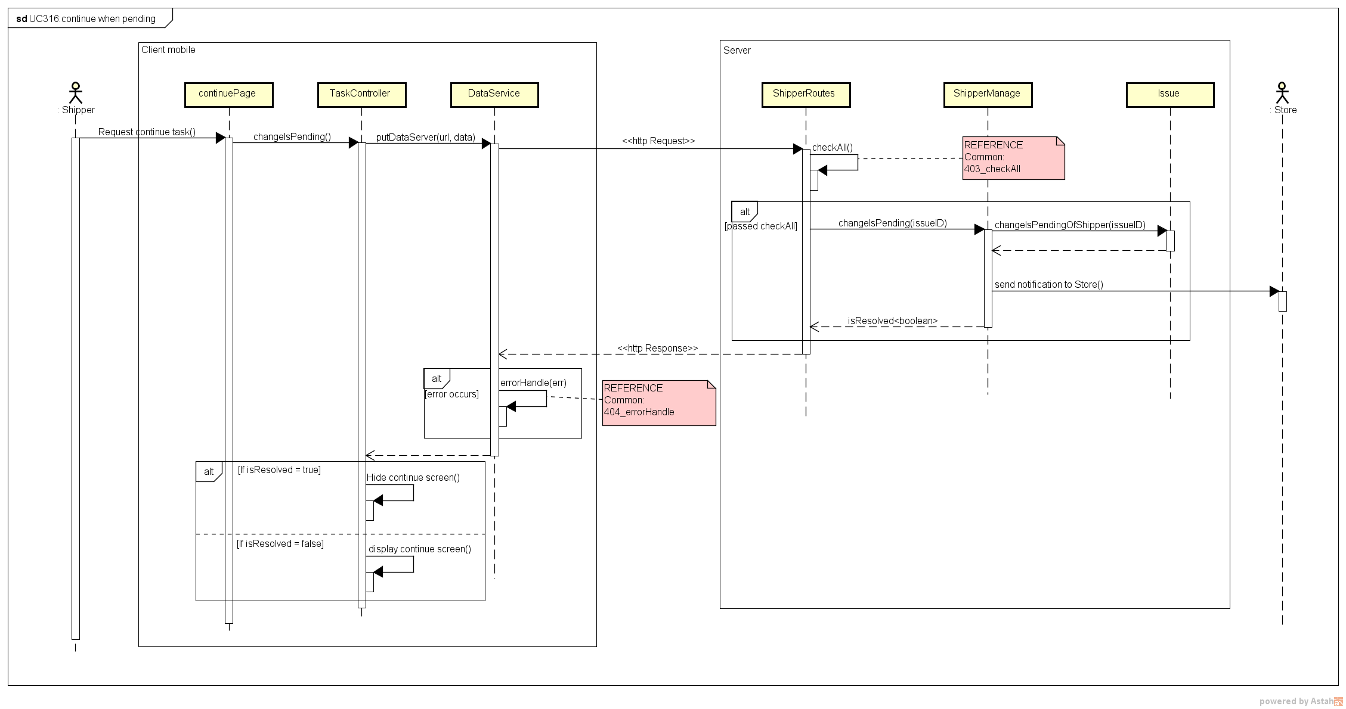***

Figure 19. Sequence Diagram of Continue When Pending use case

#### Class Description

##### SigninController

* Attributes

|  |  |  |  |  |
| --- | --- | --- | --- | --- |
| No | Attributes | Type | Default | Description |
| 1 | User | Object | {} | Content information of logged in user |

* Methods

|  |  |  |  |  |
| --- | --- | --- | --- | --- |
| No | Methods | Parameters | Return | Description |
| 1 | showError | Object | N/A | Show message error to user |
| 2 | submitFrm | N/A | N/A | Send login request to server |
| 3 | logout | N/A | N/A | Sign out, clear token save in local |

##### DetailController

* Attributes

|  |  |  |  |  |
| --- | --- | --- | --- | --- |
| No | Attributes | Type | Default | Description |
| 1 | isCancel | boolean | N/A | Is the current order canceled? |
| 2 | Shippers | Object | N/A | Information of shipper to display in map |
| 3 | Stores | Object | N/A | Information of stores to display in map |
| 4 | Customers | Object | N/A | Information of customers to display in map |
| 5 | Orders | Object | N/A | Information of orders that the shipper is having, to connect markers on map |
| 6 | Center | Object | {} | The center of the map |

* Methods

|  |  |  |  |  |
| --- | --- | --- | --- | --- |
| No | Methods | Parameters | Return | Description |
| 1 | showConfirm | int, String | N/A | Show the pop up to confirm when shipper want to move to next step |
| 2 | confirmNext | String | N/A | Send request to server without confirmation code |
| 3 | confirmNextCode | String | N/A | Send request to server with a confirmation code regard to current task and current status |
| 4 | getDetailFromServer | N/A | N/A | Get detail information of task from server |

##### HistoryController

* Attributes

|  |  |  |  |  |
| --- | --- | --- | --- | --- |
| No | Attributes | Type | Default | Description |
| 1 | historyOrders | Array | [] | Current loaded history |
| 2 | totalTask | int | 0 | The number of total tasks of the shipper |
| 3 | totalLoaded | int | 0 | The number of total tasks that displayed |
| 4 | Page | int | 1 | Last displayed page of history |

* Methods

|  |  |  |  |  |
| --- | --- | --- | --- | --- |
| No | Methods | Parameters | Return | Description |
| 1 | getHistoryFromServer | int | N/A | Load data history from server |
| 2 | getLocalData | N/A | N/A | Load data history from local storage |

##### IssueController

* Attributes

|  |  |  |  |  |
| --- | --- | --- | --- | --- |
| No | Attributes | Type | Default | Description |
| 1 | isSend | boolean | False | If the issue is send or not |
| 2 | haveIssue | boolean | False | If the shipper is having issue or not |
| 3 | issueCategories | Array | [] | List categories of issue |
| 4 | listReasons | Array | [] | List reasons of issue |
| 5 | pendingReasons | Array | [] | List reasons to pending a task |
| 6 | cancelReasons | Array | [] | List reason to cancel a task |

* Methods

|  |  |  |  |  |
| --- | --- | --- | --- | --- |
| No | Methods | Parameters | Return | Description |
| 1 | getAllTaskOfShipper | N/A | N/A | Get list current tasks of the shipper |
| 2 | formatData | Object | Object | Format data to display in view |
| 3 | parseMulti | Array | String | Parse a list into a string |
| 4 | showLoading | N/A | N/A | Show a loading icon on the screen |

##### ProfileController

* Attributes

|  |  |  |  |  |
| --- | --- | --- | --- | --- |
| No | Attributes | Type | Default | Description |
| 1 | Profile | Object | {} | Profile information of the shipper |

* Methods

|  |  |  |  |  |
| --- | --- | --- | --- | --- |
| No | Methods | Parameters | Return | Description |
| 1 | getProfile | N/A | N/A | Request into server to get profile information of shipper display to screen |

##### TaskController

* Attributes

|  |  |  |  |  |
| --- | --- | --- | --- | --- |
| No | Attributes | Type | Default | Description |
| 1 | haveIssue | boolean | false | If the shipper is having an issue |

* Methods

|  |  |  |  |  |
| --- | --- | --- | --- | --- |
| No | Methods | Parameters | Return | Description |
| 1 | showLoading | N/A | N/A | Display a loading icon on screen |
| 2 | showAlert | String | N/A | Show a pop up to shipper |
| 3 | getAllTaskBeIssued | N/A | N/A | Get a list tasks having issue and update haveIssue attribute |
| 4 | changeIsPending | int | N/A | Send request to server to continue when shipper resolved his issue |
| 5 | getListOfTask | N/A | N/A | Get list of current task of the shipper |
| 6 | formatData | Object | Object | Format data for html view |
| 7 | isIssued | Array | boolean | Check if the shipper is having issue |

##### MapController

* Attributes

|  |  |  |  |  |
| --- | --- | --- | --- | --- |
| No | Attributes | Type | Default | Description |
| 1 | haveIssue | boolean | false | If the shipper is having an issue |

* Methods

|  |  |  |  |  |
| --- | --- | --- | --- | --- |
| No | Methods | Parameters | Return | Description |
| 1 | drawArrow | Object, Object, String, String, Object, Object | N/A | Push list of new order information into the *arrows* attribute |
| 2 | resetArrows | N/A | N/A | Reset value of *arrows* attribute to default |
| 3 | displayRelationship | Object, Object, Object, Object | N/A | Draw arrows on the map, bases on data in *arrows* attribute |

##### AuthService

* Attributes

|  |  |  |  |  |
| --- | --- | --- | --- | --- |
| No | Attributes | Type | Default | Description |
| 1 | Tag | String | EHID | Name of the local data that holding token information |

* Methods

|  |  |  |  |  |
| --- | --- | --- | --- | --- |
| No | Methods | Parameters | Return | Description |
| 1 | saveToken | String | N/A | Save token data into the local storage |
| 2 | signIn | Object | N/A | Send sign in request to server |
| 3 | isLogged | N/A | boolean | Check if the user is logged in |
| 4 | isRightRole | int | boolean | Check if the user has role that can access |
| 5 | signOut | N/A | N/A | Log out, clear token in local storage |
| 6 | getCurrentInfoUser | N/A | Object | Return the information of current logged in user |
| 7 | getProfileUser | N/A | Object | Return the profile information of current logged in user |

##### DataService

* Attributes

|  |  |  |  |  |
| --- | --- | --- | --- | --- |
| No | Attributes | Type | Default | Description |
| 1 | dataFactory | Object | {} | The object to provide API functions for calling from other places |

* Methods

|  |  |  |  |  |
| --- | --- | --- | --- | --- |
| No | Methods | Parameters | Return | Description |
| 1 | getDataServer | String | Object | Send http request to server with GET method |
| 2 | postDataServer | String, Object | Object | Send http request to server with POST method |
| 3 | putDataServer | String, Object | Object | Send http request to server with PUT method |
| 4 | deleteDataServer | String | Object | Send http request to server with DELETE method |
| 5 | errorHandle | Object | N/A | Handle the error return of sending http request, log out if the error has status 401 (Unauthorized) |

##### LocalDataService

* Attributes

|  |  |  |  |  |
| --- | --- | --- | --- | --- |
| No | Attributes | Type | Default | Description |
| N/A | N/A | N/A | N/A | N/A |

* Methods

|  |  |  |  |  |
| --- | --- | --- | --- | --- |
| No | Methods | Parameters | Return | Description |
| 1 | Set | String, String | N/A | Save a pair of String: key and value into local storage |
| 2 | setObject | String, Object | N/A | Save a pair of: key (String) and value(Object) into local storage |
| 3 | Get | String, String | String | Return value of a key save in local storage; if not found, return a default value |
| 4 | getObject | String | Object | Return value of a key save in local storage and parse to object; if not found, return a default value is {} |

##### MapService

* Attributes

|  |  |  |  |  |
| --- | --- | --- | --- | --- |
| No | Attributes | Type | Default | Description |
| 1 | shipperMarkers | Array | [] | List of shipper markers to display on map |
| 2 | storeMarkers | Array | [] | List of store markers to display on map |
| 3 | customerMarkers | Array | [] | List of customer markers to display on map |
| 4 | Orders | Object | {} | List of order to connect markers on map |
| 5 | returnedShipperMarkers | Array | [] | List of shipper markers that receive from server |
| 6 | returnedStoreMarkers | Array | [] | List of store markers that receive from server |
| 7 | returnedCustomerMarkers | Array | [] | List of customer markers that receive from server |
| 8 | returnedOrders | Object | {} | List information of orders that receive from server |
| 9 | currentMode | Object | N/A | The mode of markers displayed on map |
| 10 | Api | Object | N/A | The object to provide |

* Methods

|  |  |  |  |  |
| --- | --- | --- | --- | --- |
| No | Methods | Parameters | Return | Description |
| 1 | setMode | Object | N/A | Set mode of markers displayed on map |
| 2 | getMode | N/A | Object | Get the mode of markers on map |
| 3 | updateReturnedShippers | N/A | N/A | Update *returnedShipperMarkers* attribute after receive data from socket server |
| 4 | updateReturnedStores | N/A | N/A | Update *returnedStoreMarkers* attribute after receive data from socket server |
| 5 | updateReturnedCustomers | N/A | N/A | Update *returnedCustomerMarkers* attribute after receive data from socket server |
| 6 | updateReturnedOrders | N/A | N/A | Update *returnedOrders* attribute after receive data from socket server |
| 7 | updateReturnedValues | N/A | N/A | Call method 3, 4, 5, 6 |
| 8 | getShipperMarkers | N/A | Array | Return *returnedShipperMarkers* |
| 9 | getStoreMarkers | N/A | Array | Return *returnedStoreMarkers* |
| 10 | getCustomerMarkers | N/A | Array | Return *returnedCustomerMarkers* |
| 11 | getOrders | N/A | Object | Return *returnedOrders* |
| 12 | setMapData | Object | N/A | Set data for map |

### Web Application

#### Web Client

##### **Admin**

###### 2.2.1.1.1. Add Store

***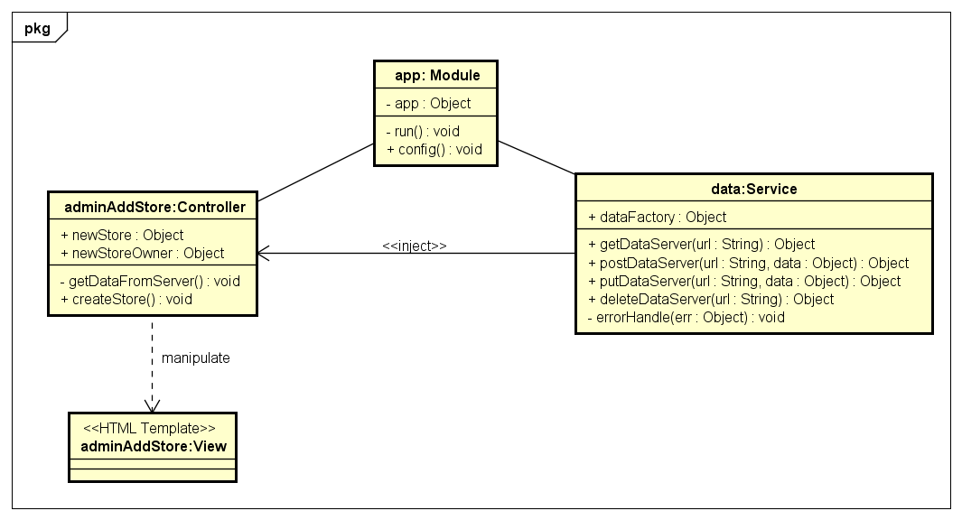***

Figure 20. Object Diagram of Add Store use case

***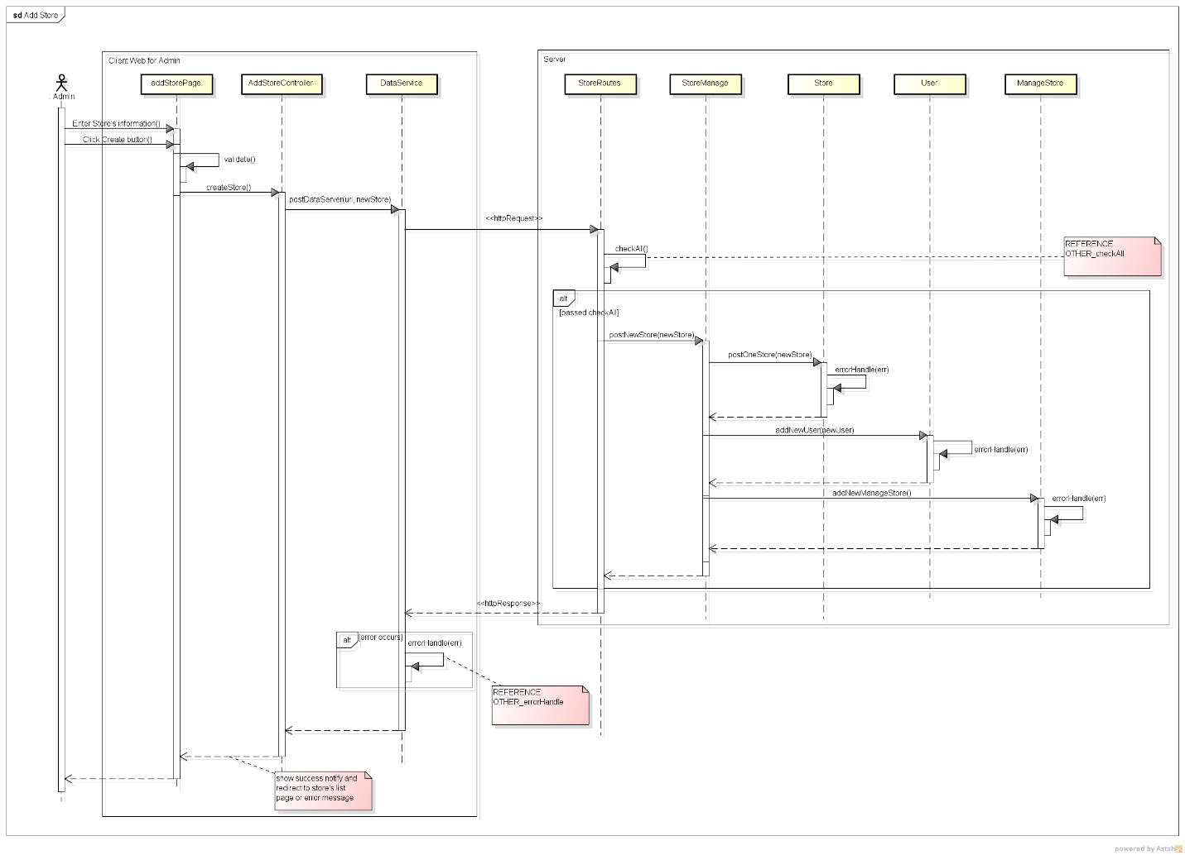***

Figure 21. Sequence Diagram of Add Store use case

###### 2.2.1.1.2. View Store’s List

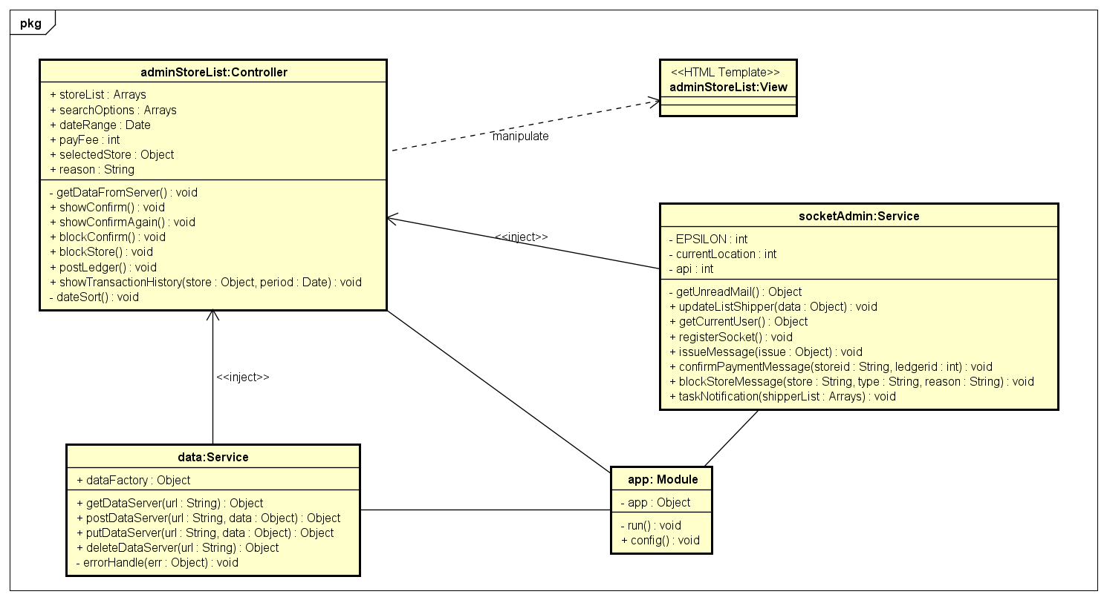

Figure 22. Object Diagram of View Store’s List use case

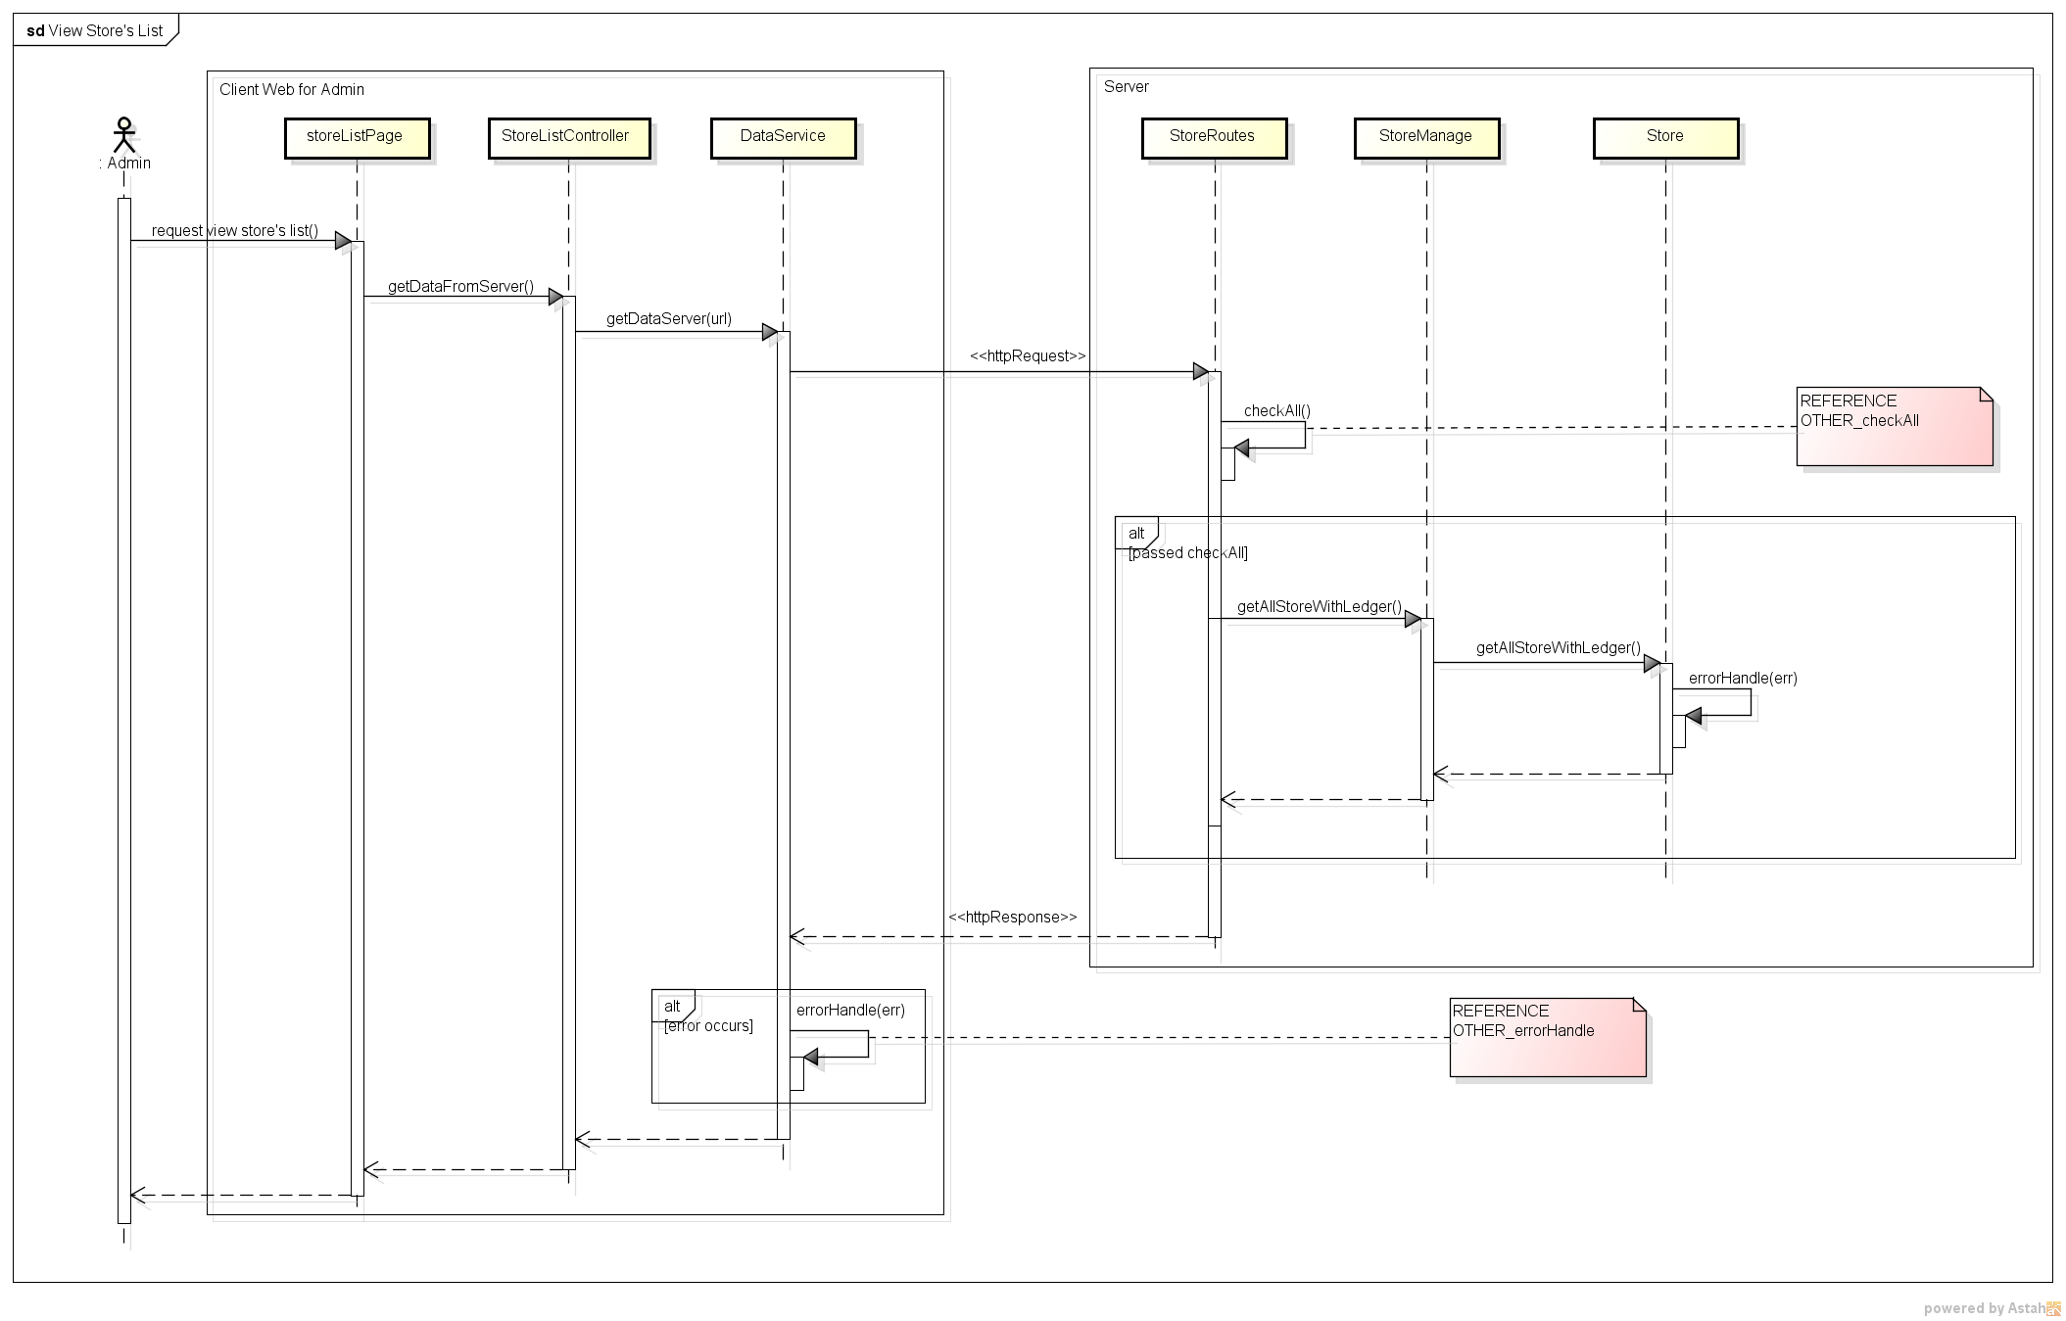

Figure 23. Sequence Diagram of View Store’s List use case

###### 2.2.1.1.3. Block/Unlock Store

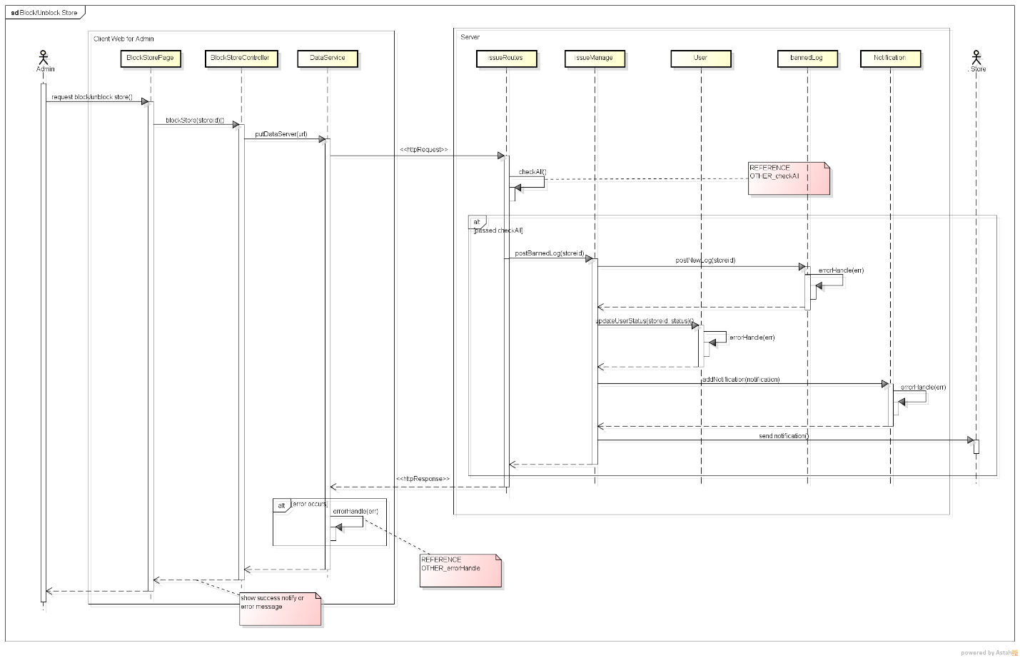

Figure 24. Sequence Diagram of Block/Unblock Store use case

###### 2.2.1.1.4. View Store’s Detail

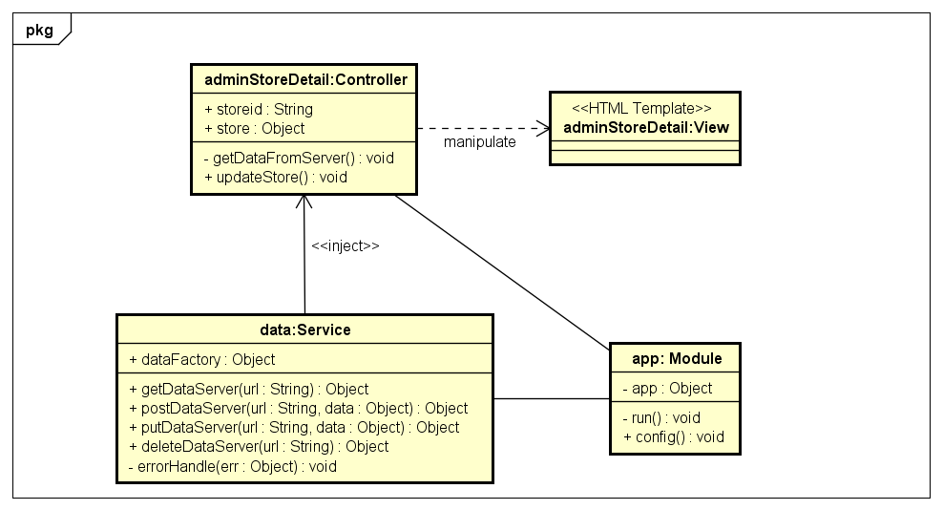

Figure 25. Object Diagram of View Store’s Detail use case

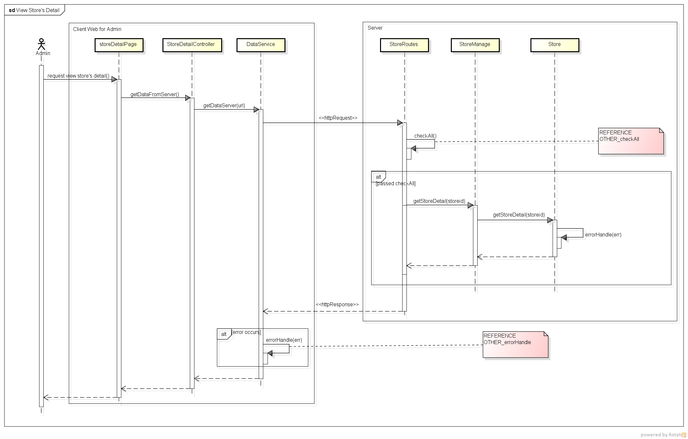

Figure 26. Sequence Diagram of View Store’s Detail use case

###### 2.2.1.1.5. Confirm Payment

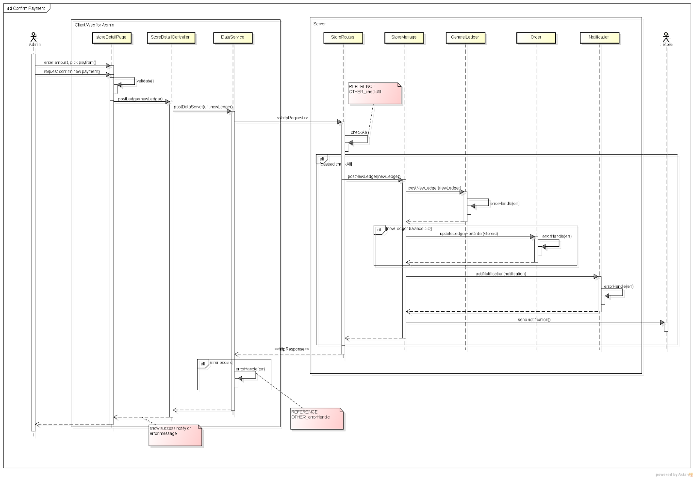

Figure 27. Sequence Diagram of Confirm Payment use case

###### 2.2.1.1.6. View Transaction History

***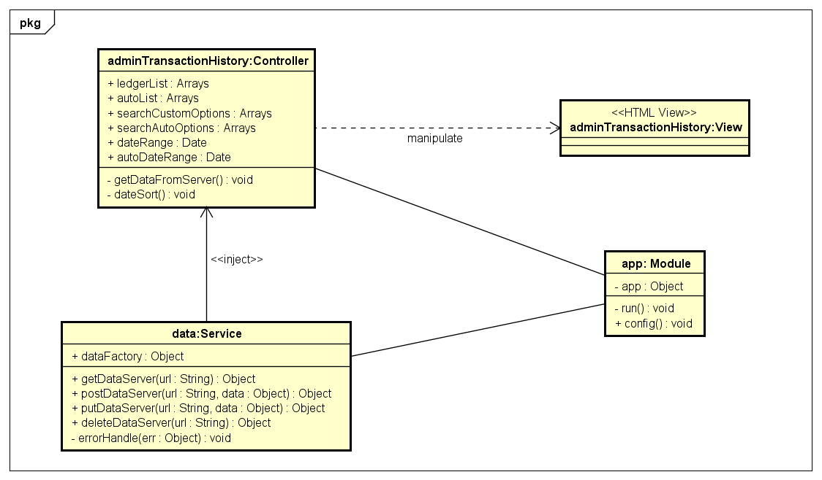***

Figure 28. Object Diagram of View Transaction History use case

***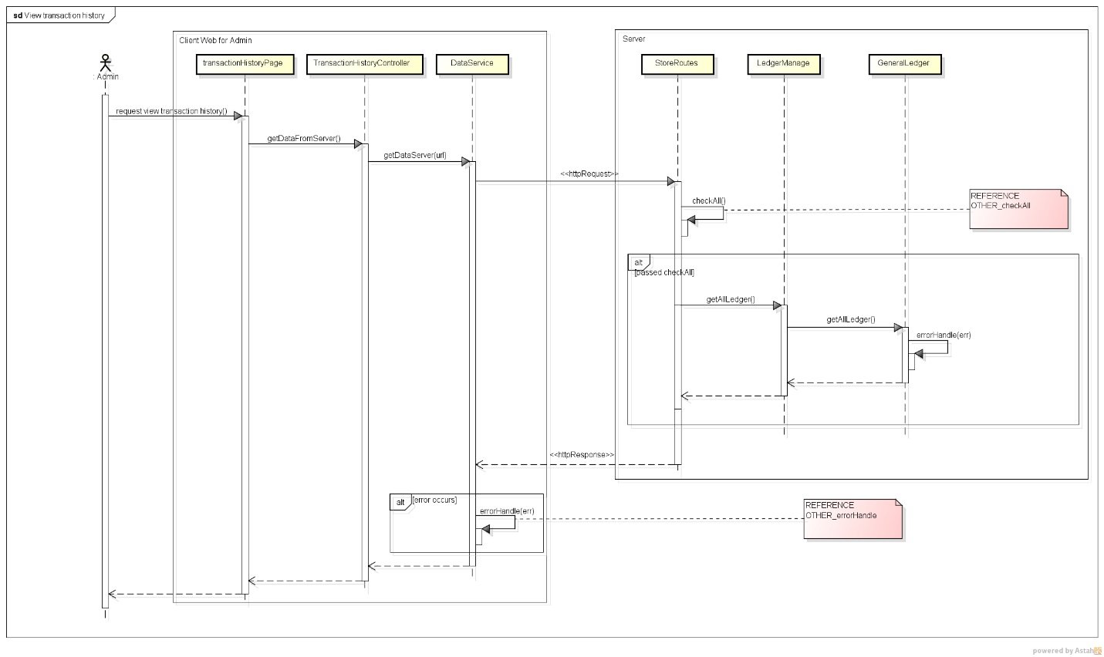***

Figure 29 Sequence Diagram of View Transaction History use case

###### 2.2.1.1.7. Add Shipper

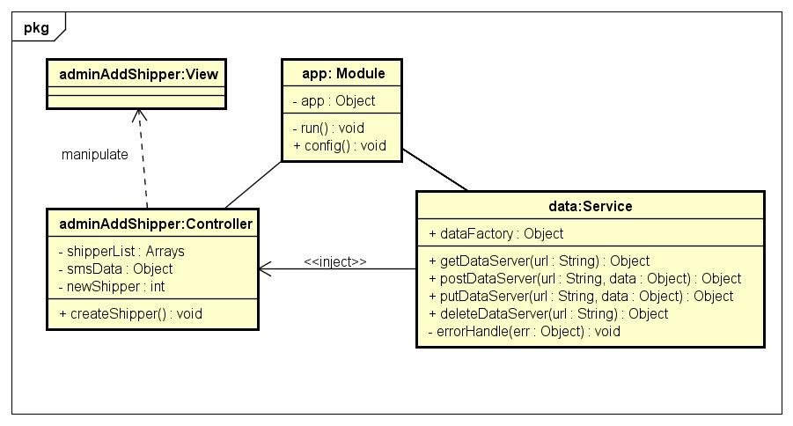

Figure 30. Object Diagram of Add Shipper use case

***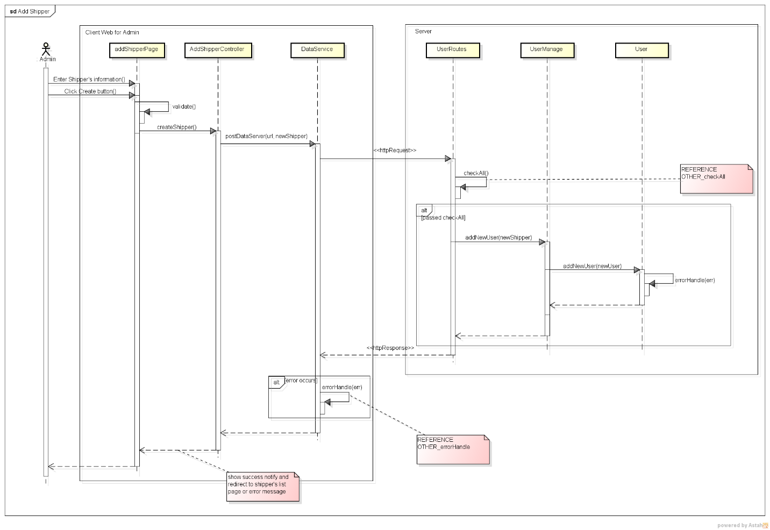***

Figure 31. Sequence Diagram of Add Shipper use case

###### 2.2.1.1.8. View Shipper’s List

***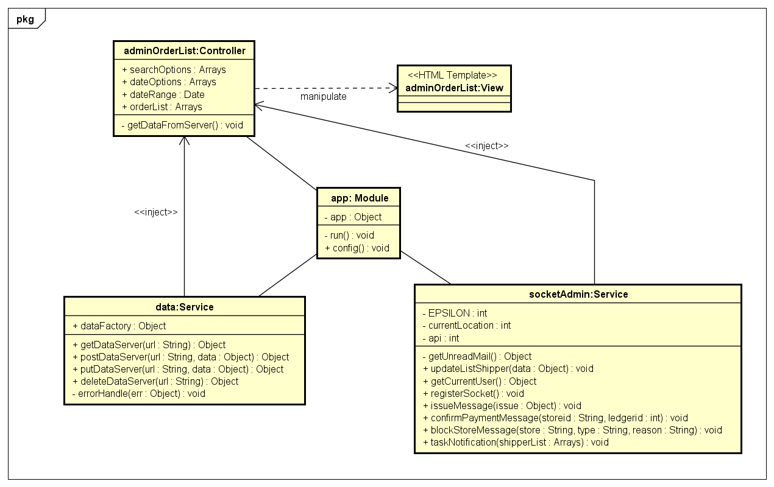***

Figure 32. Object Diagram of View Shipper’s List use case

***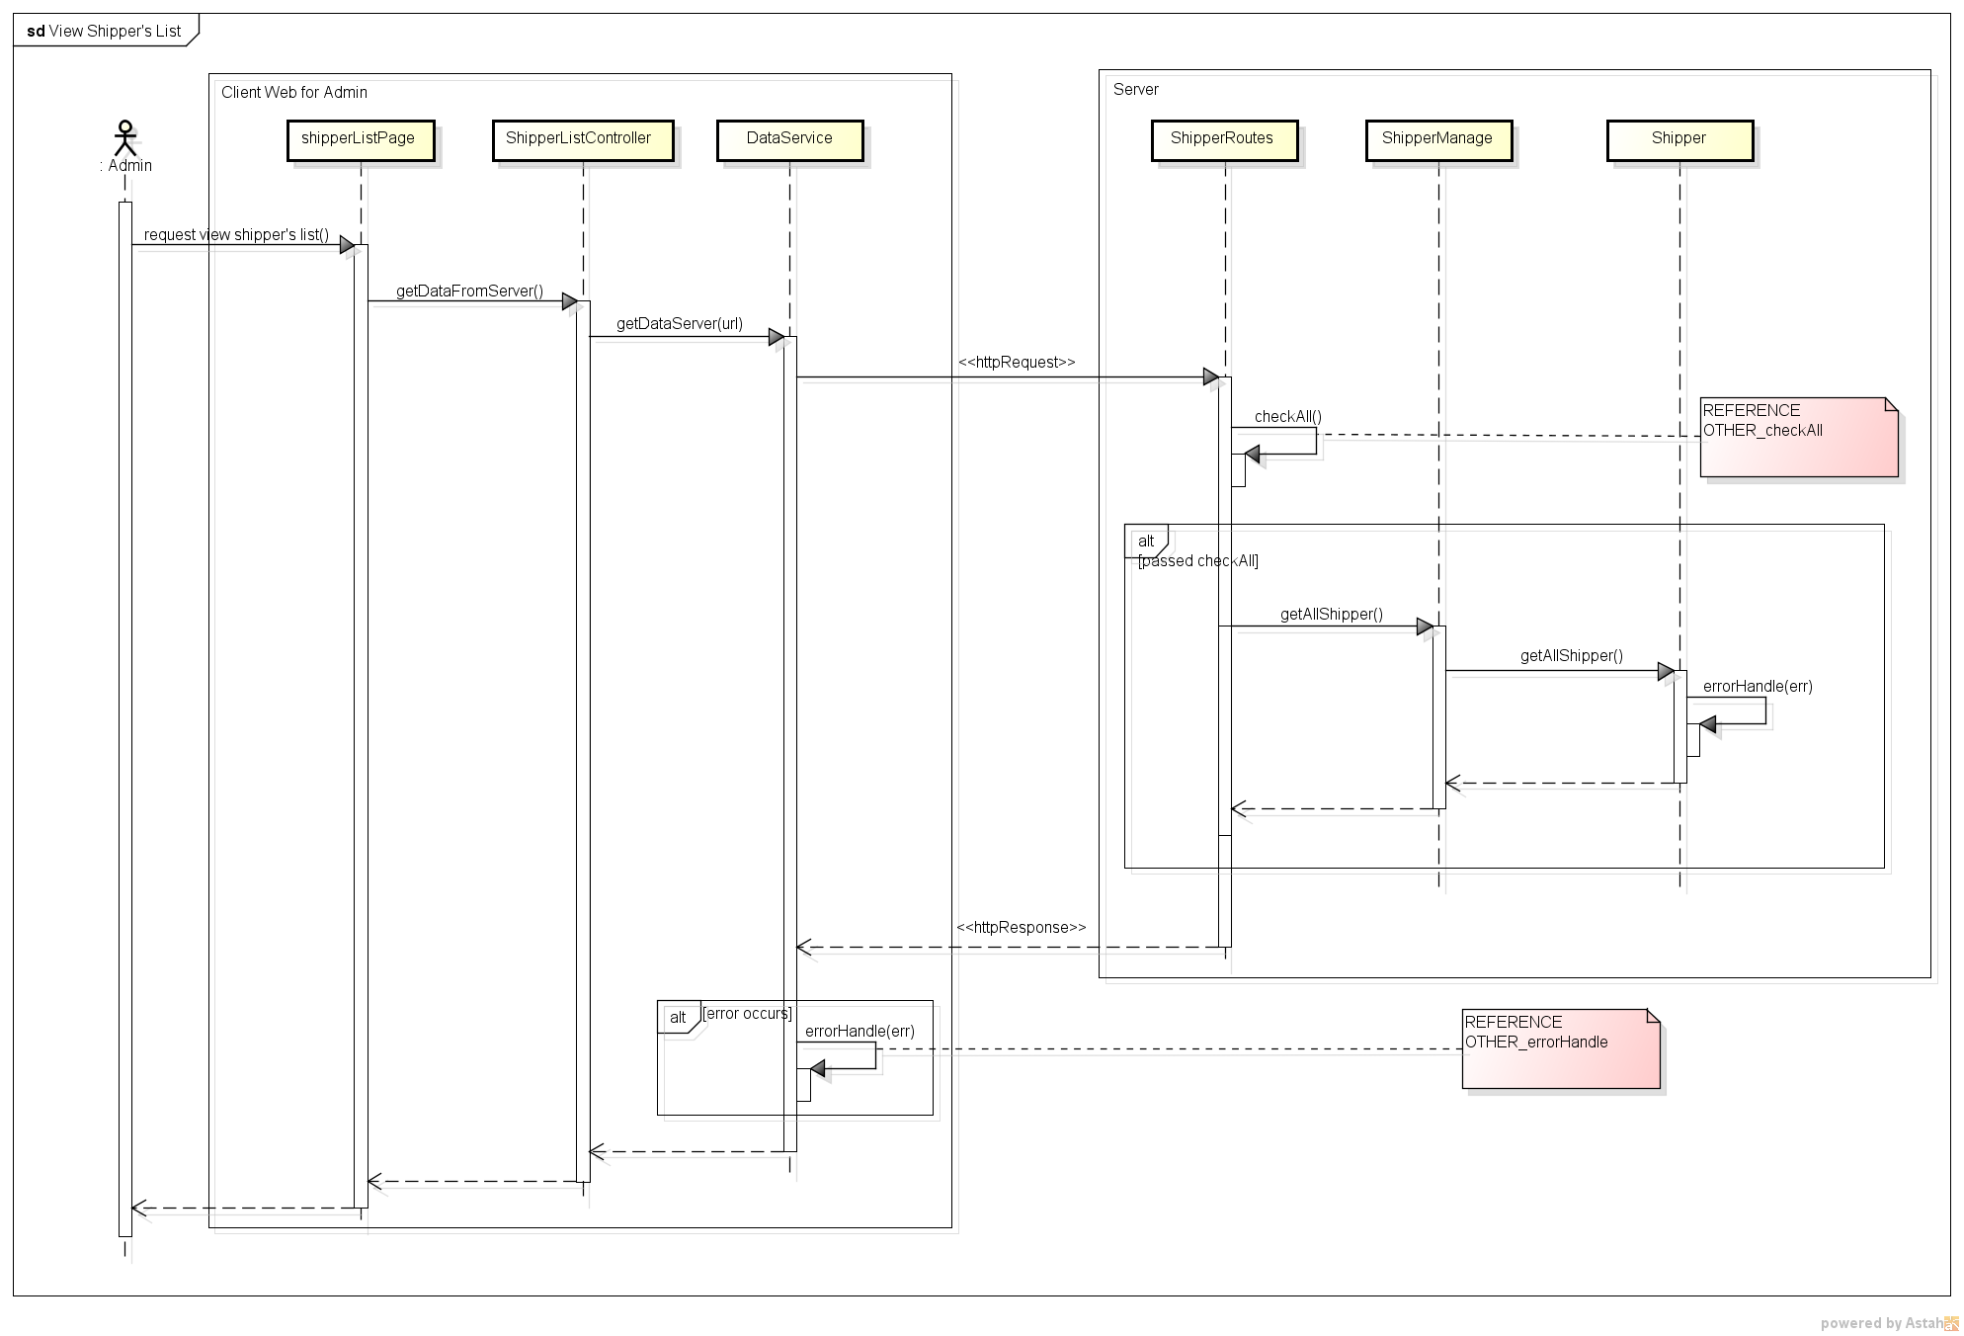***

Figure 33. Sequence Diagram of View Shipper’s List use case

###### 2.2.1.1.9. View Order’s List

***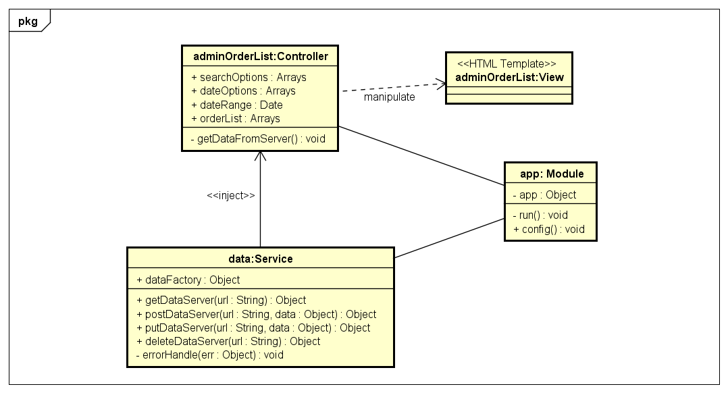***

Figure 34. Object Diagram of View Order’s List use case

***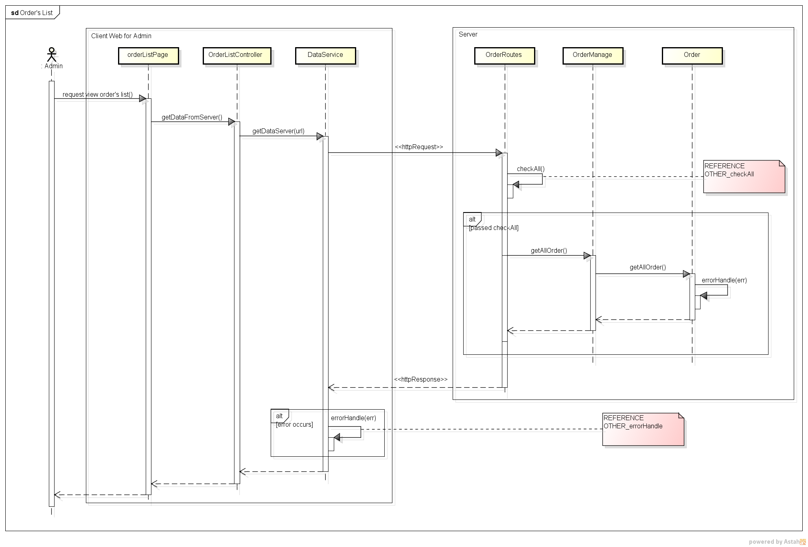***

Figure 35. Sequence Diagram of View Order’s List use case

###### 2.2.1.1.10. View User’s Detail

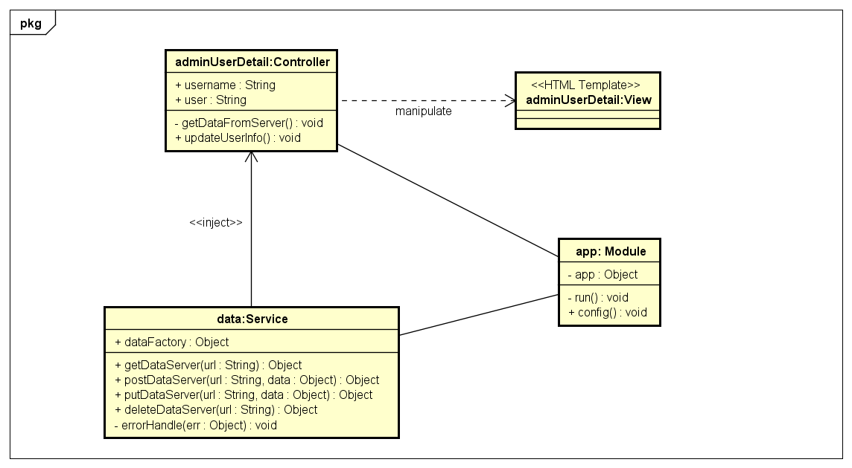

Figure 36. Object Diagram of View User’s Detail use case

***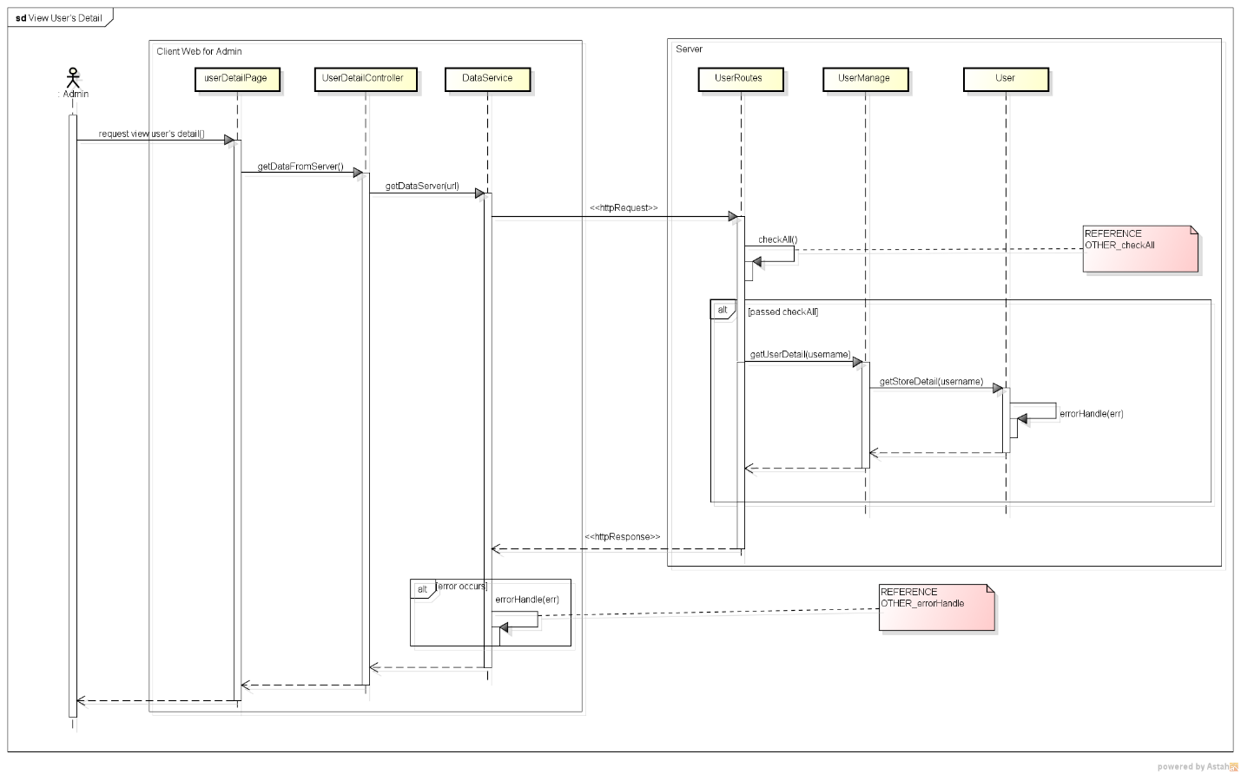***

Figure 37. Sequence Diagram of View User’s Detail use case

###### 2.2.1.1.11. Update User’s Profile

***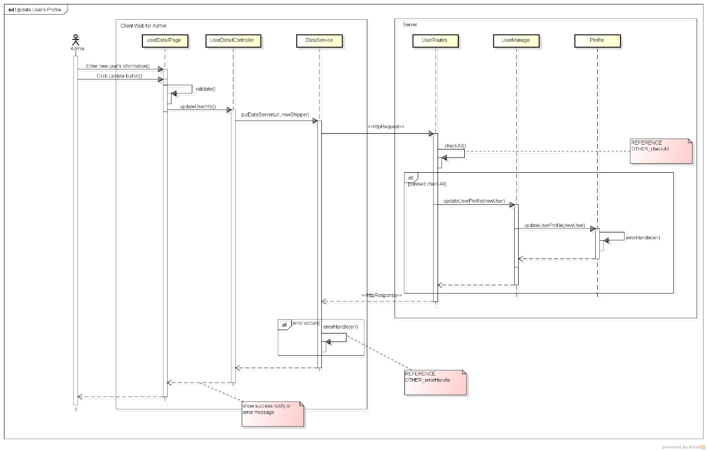***

Figure 38. Sequence Diagram of Update User’s Profile use case

###### 2.2.1.1.12. Update Store’s Information

***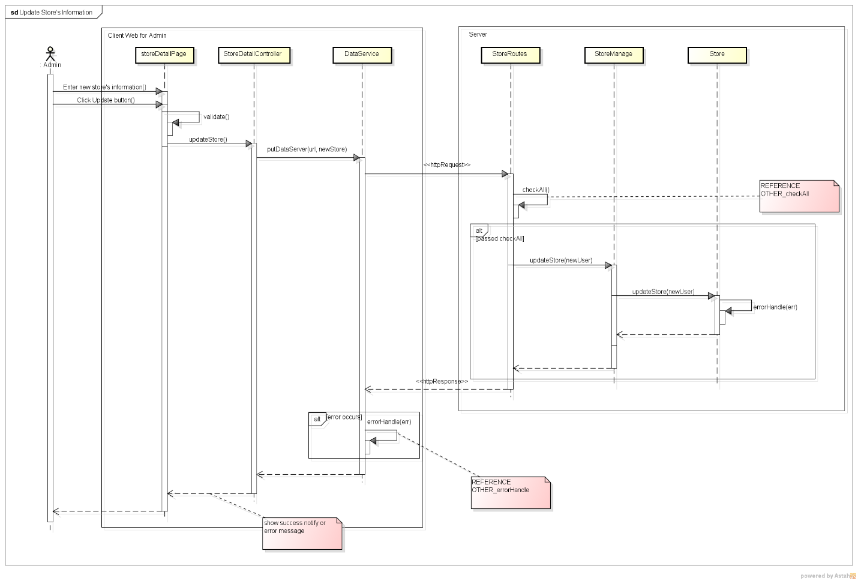***

Figure 39. Sequence Diagram of Update Store’s Information use case

###### 2.2.1.1.13. Assign Task

***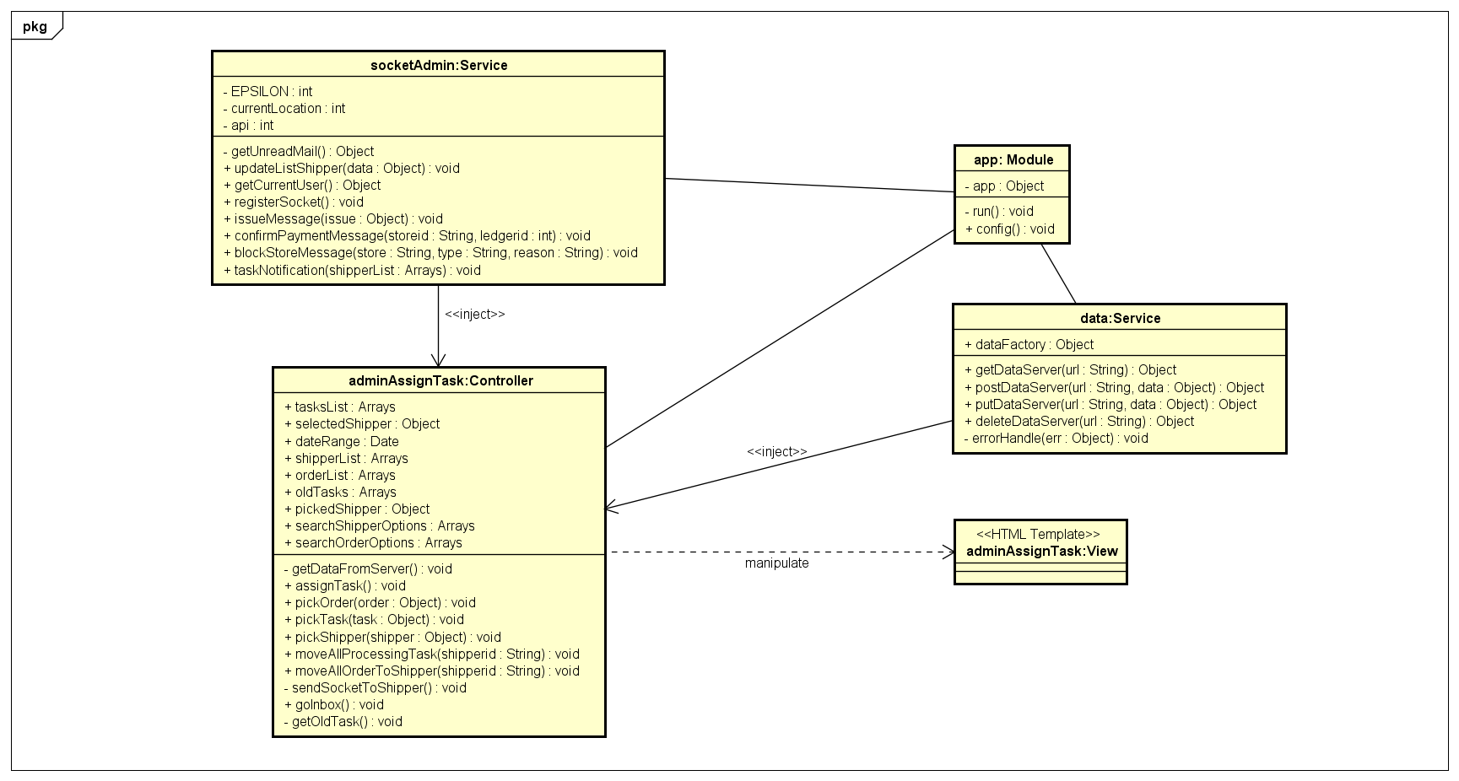***

Figure 40. Object Diagram of Assign Task use case

***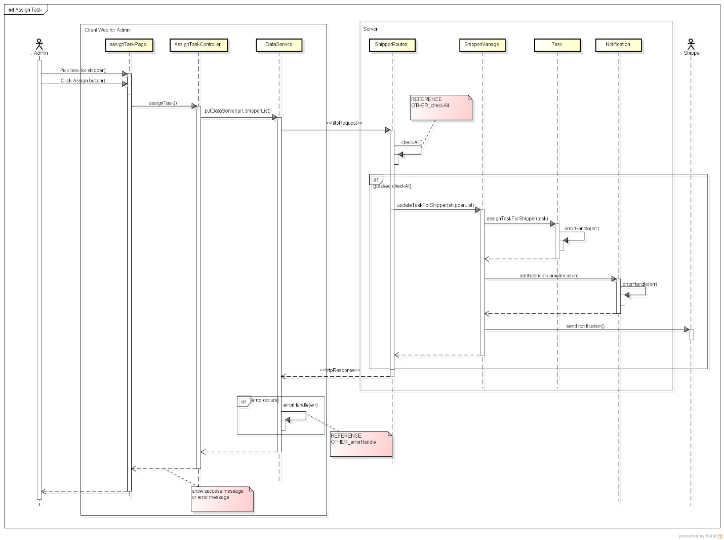***

Figure 41. Sequence Diagram of Assign Task use case

###### 2.2.1.1.14. View Dashboard

***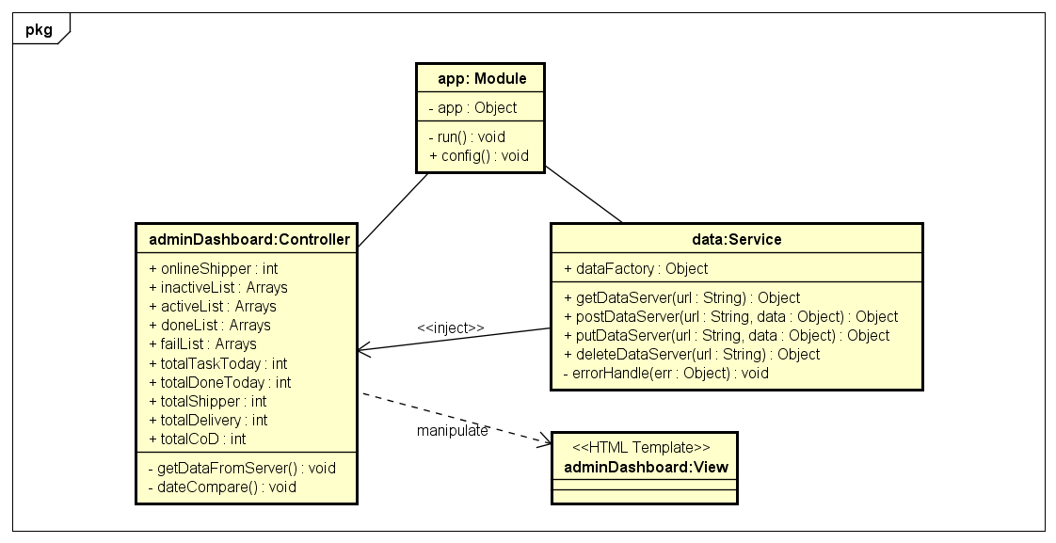***

Figure 42. Object Diagram of View Dashboard use case

***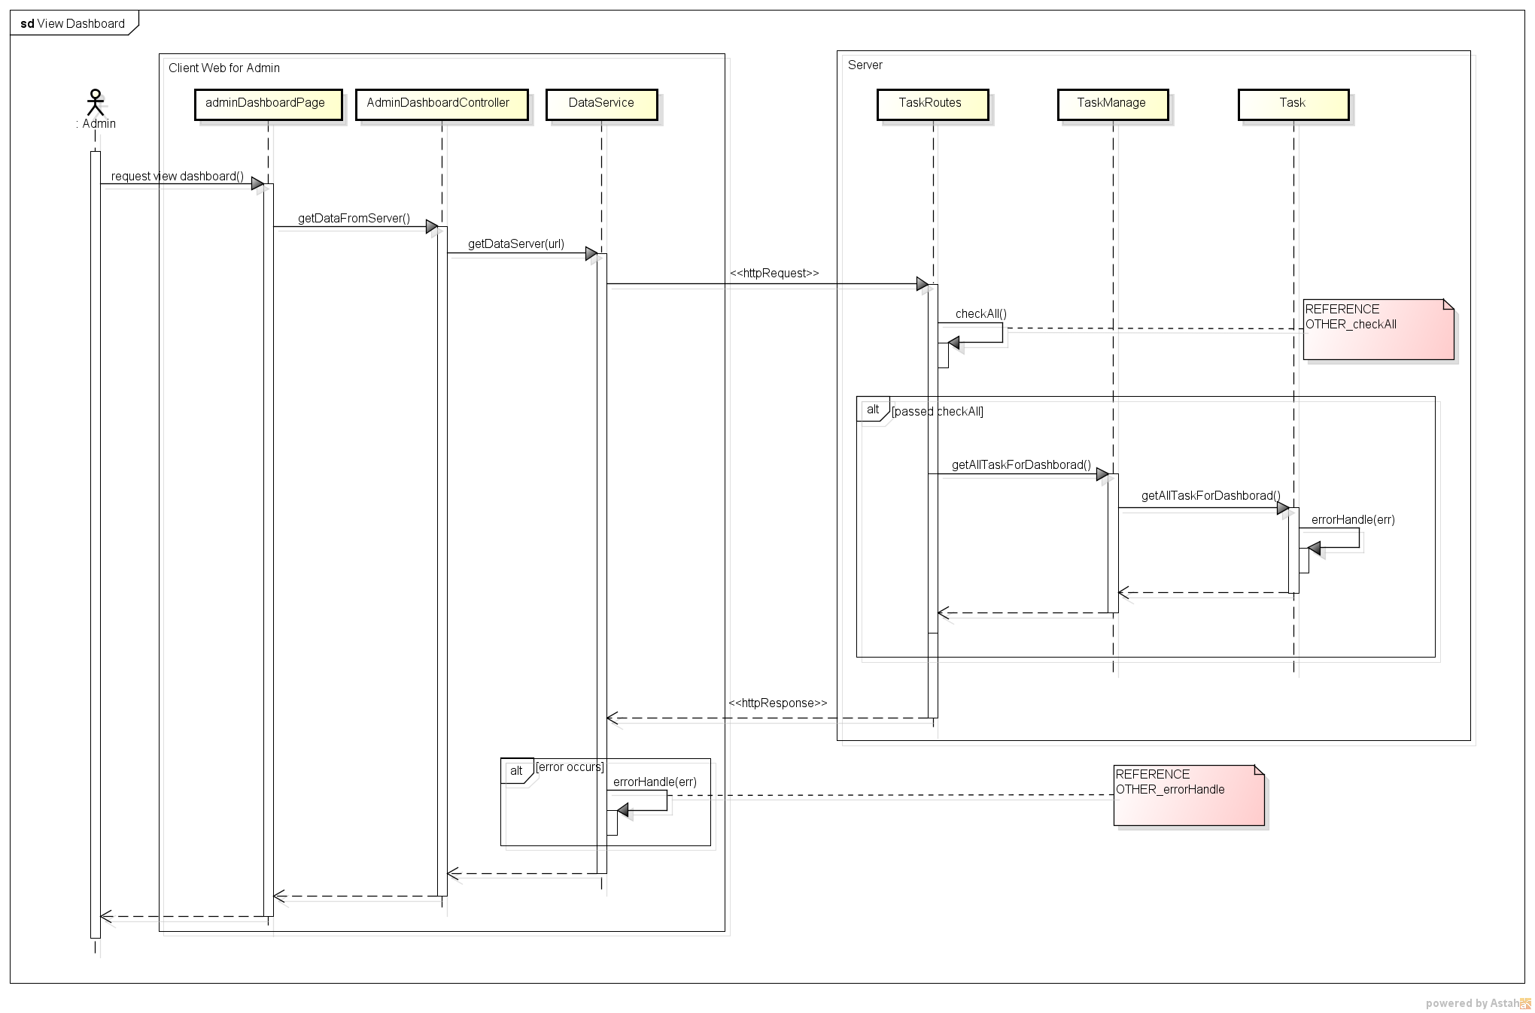***

Figure 43. Sequence Diagram of View Dashboard use case

###### 2.2.1.1.15. View IssueBox

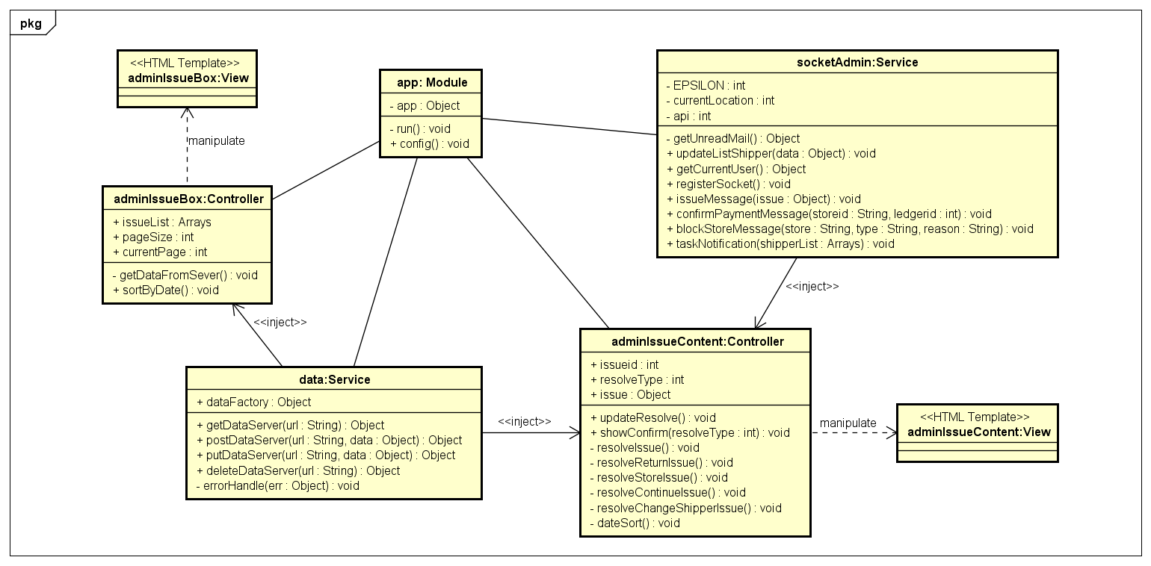

Figure 44. Object Diagram of View IssueBox use case

***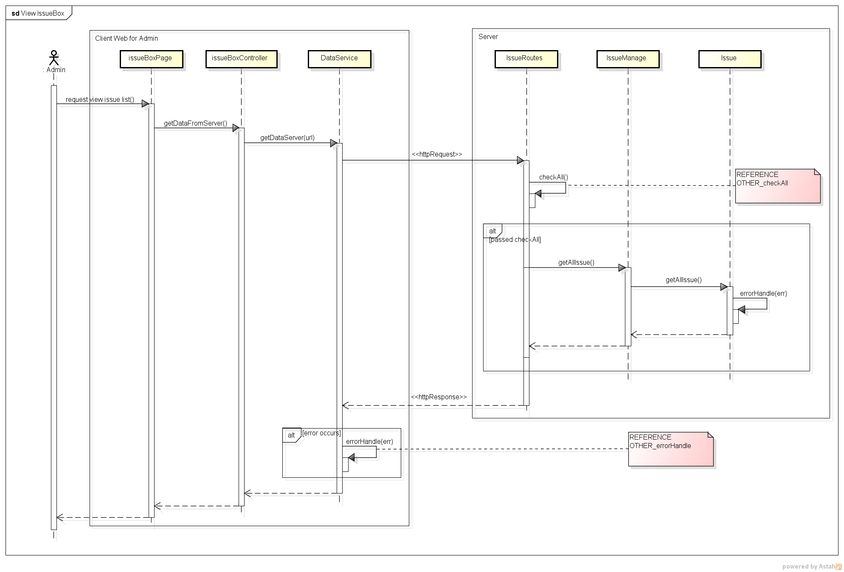***

Figure 45. Sequence Diagram of View IssueBox use case

###### 2.2.1.1.16. Resolve Issue

***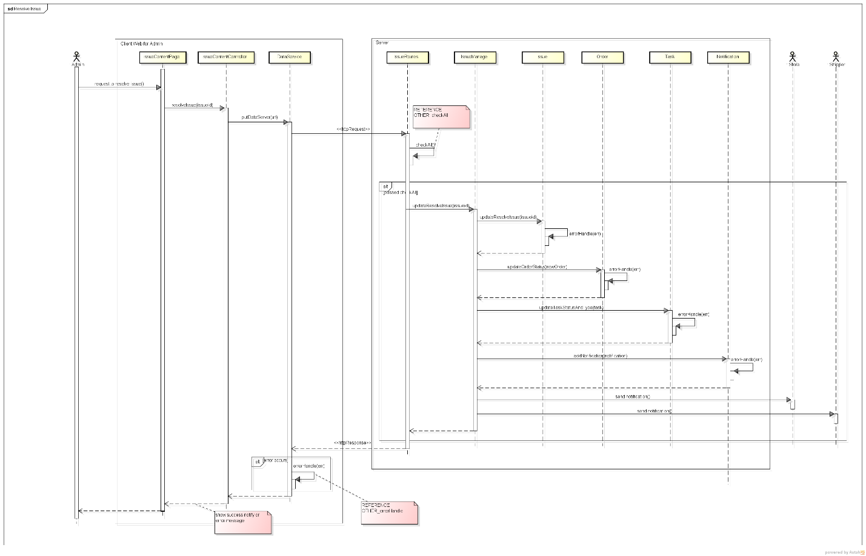***

Figure 46. Sequence Diagram of Resolve Issue use case

###### 2.2.1.1.17. View Task’s List

***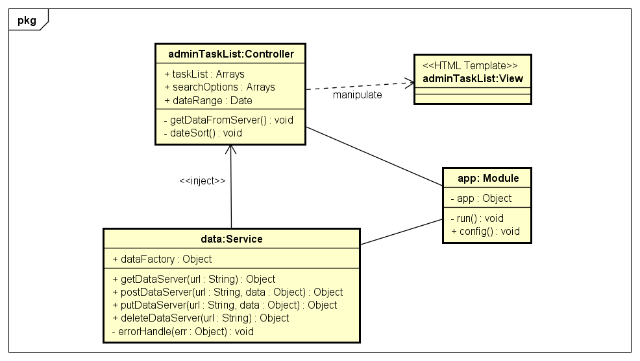***

Figure 47. Object Diagram of View Task’s List use case

***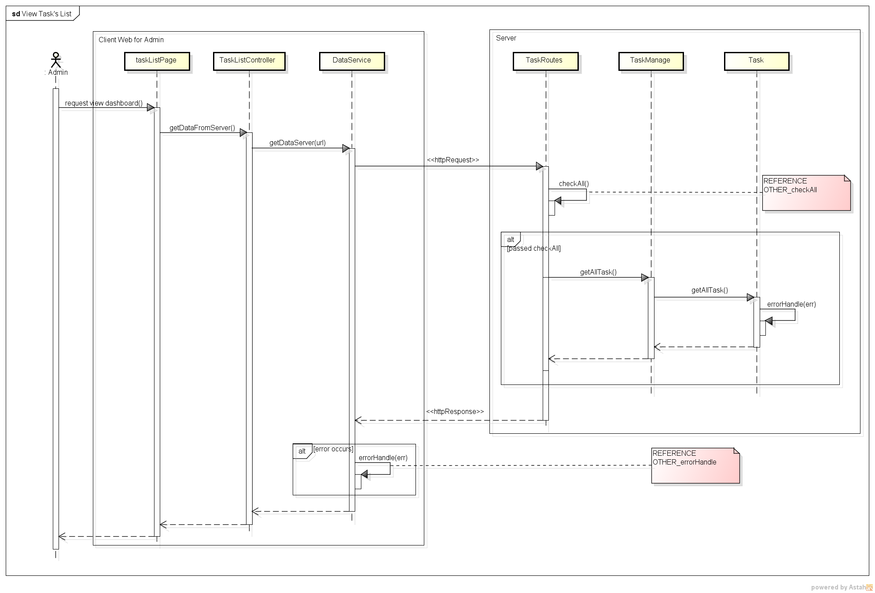***

Figure 48. Sequence Diagram of View Task’s List use case

##### **Store**

###### 2.2.1.2.1. View Dashboard

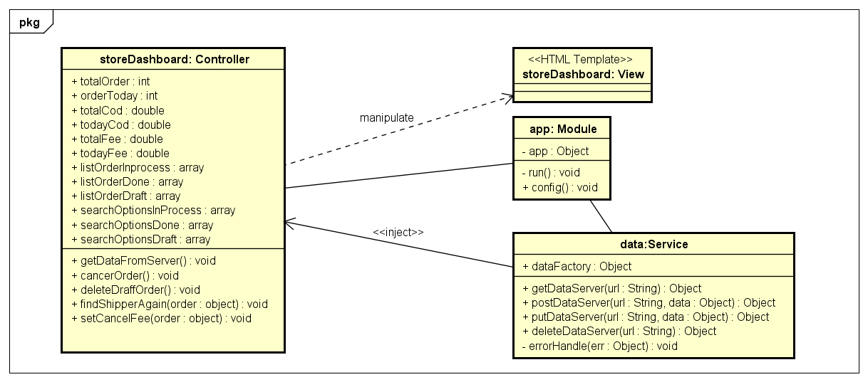

Figure 49. Object Diagram of View Dashboard use case

###### *E:\3S\Develop\Users\HuyTDH\SAD\PNG\KW_DD_HuyTDH_ver1.0\DD_SD_315 View History.png*2.2.1.2.2. View Profile

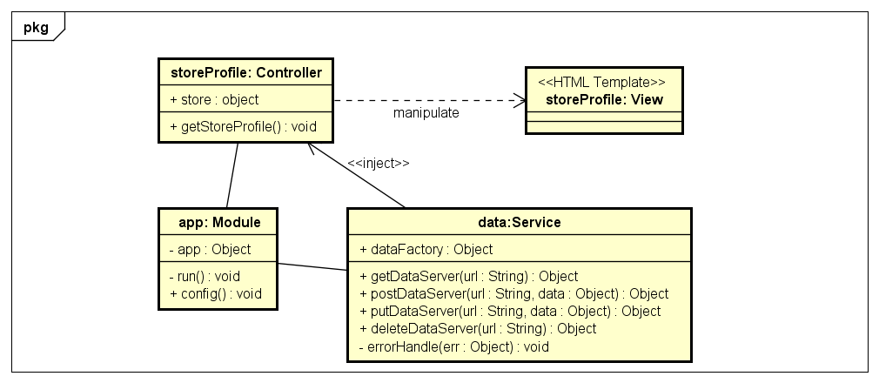

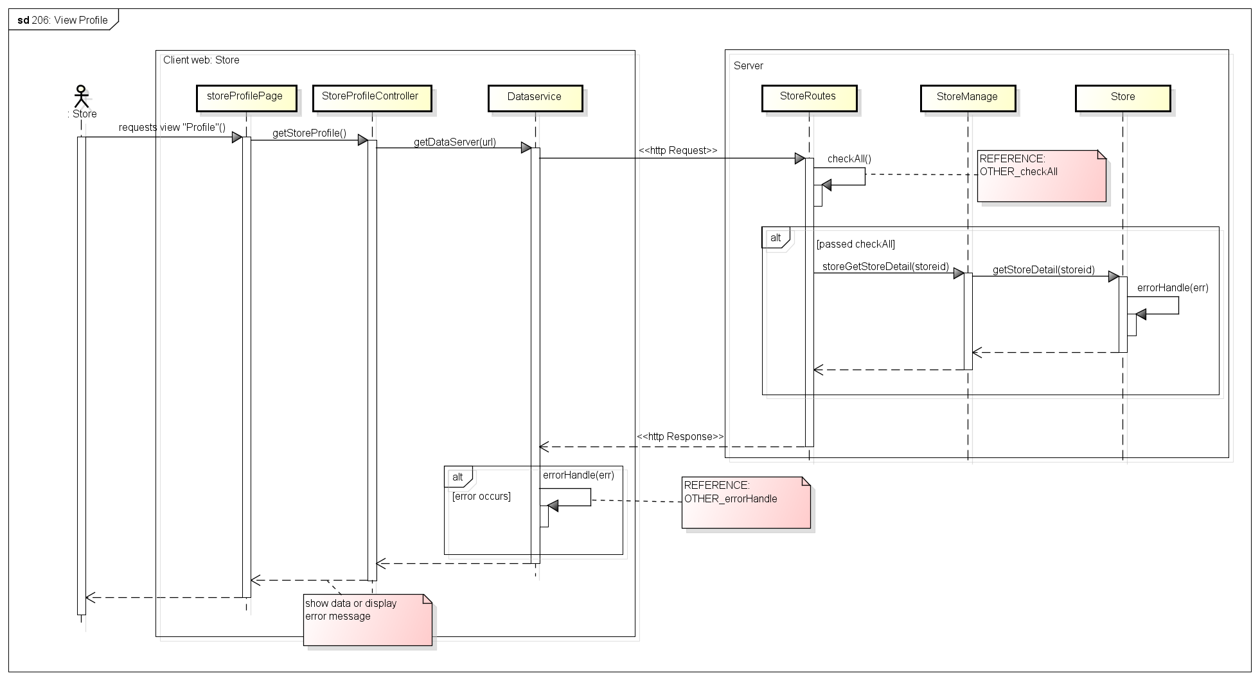

###### 2.2.1.2.3. Create Order

***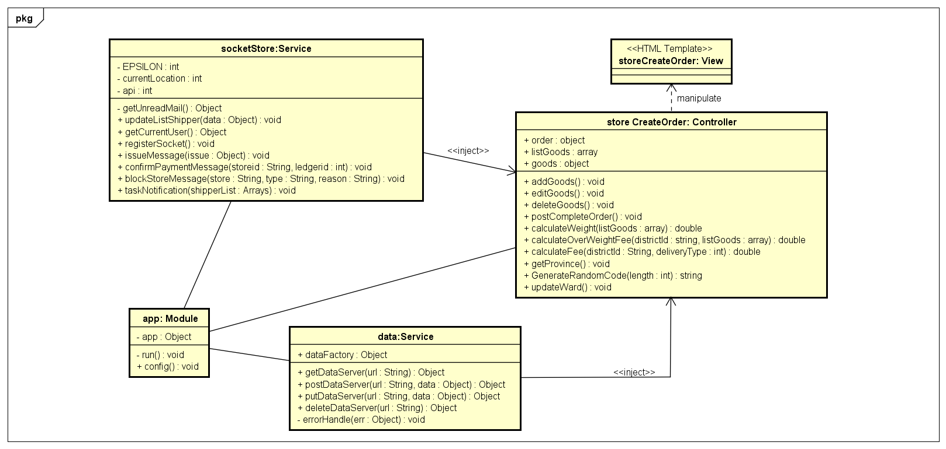***

***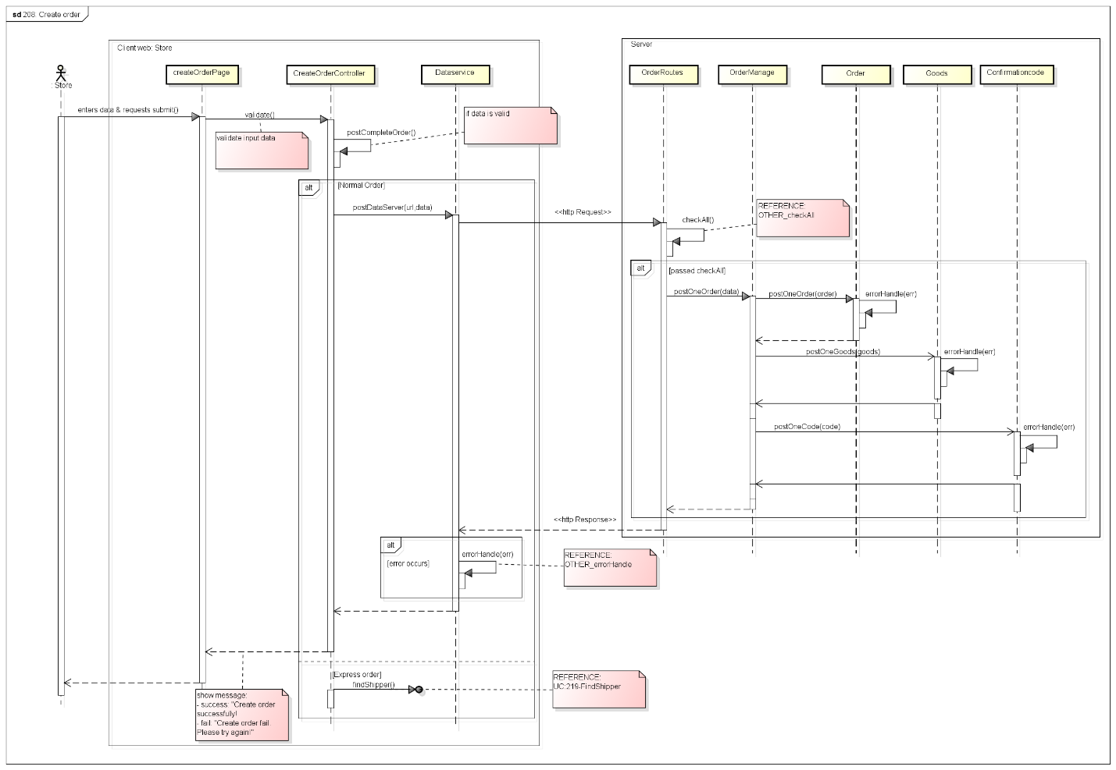***

###### 2.2.1.2.4. Find Shipper

***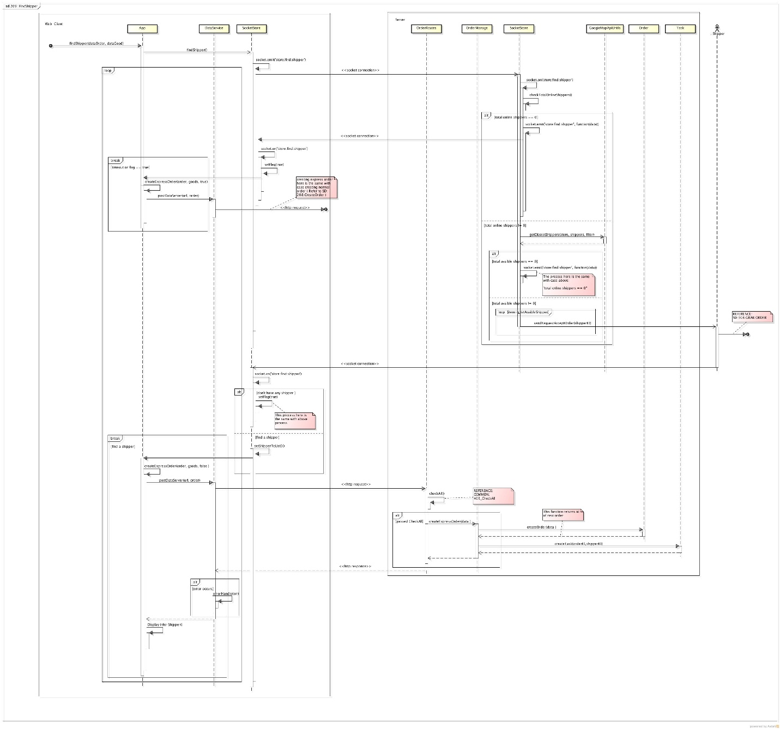***

###### 2.2.1.2.5. Edit Order

***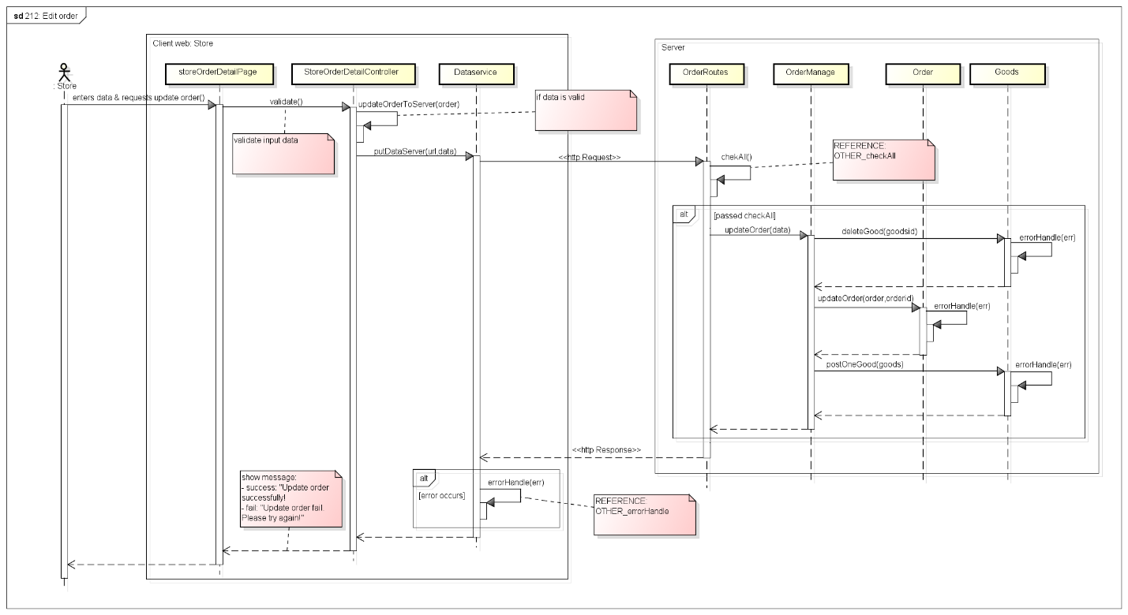***

###### 2.2.1.2.6. View Order’s History

***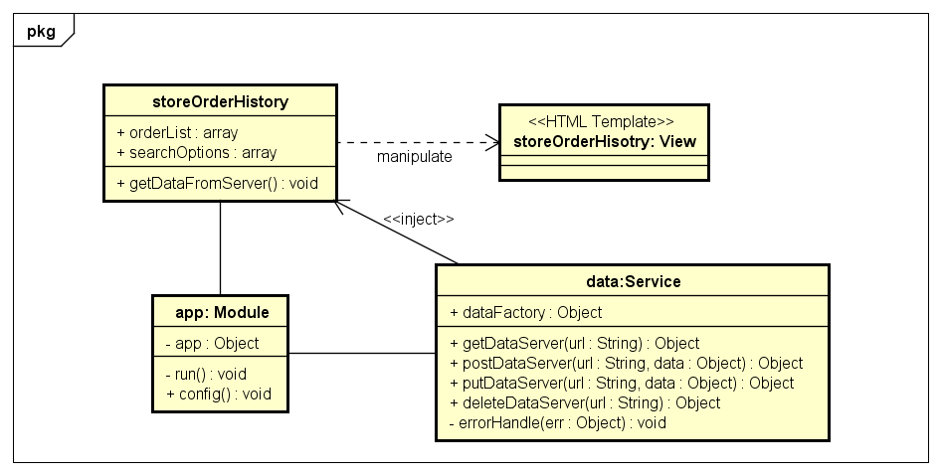***

***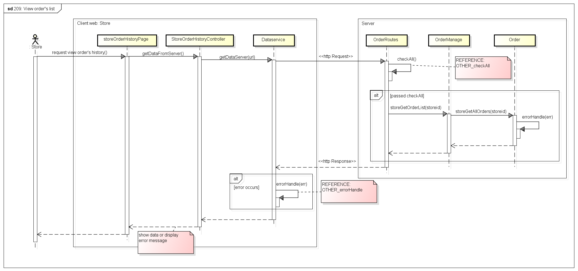***

###### 2.2.1.2.7. Search Order

***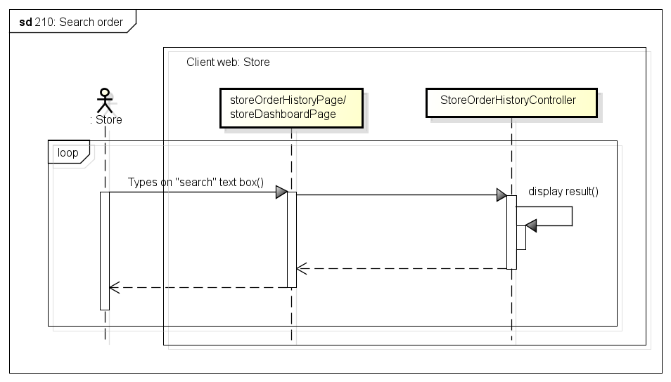***

###### 2.2.1.2.8. Cancel Order

***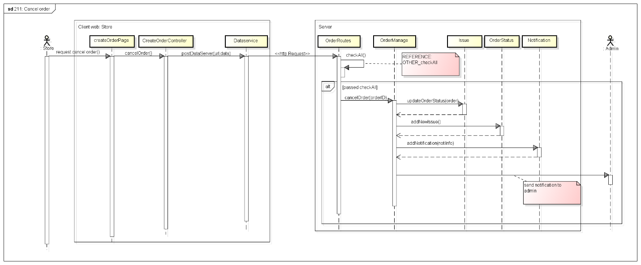***

###### 2.2.1.2.9. Delete Order

***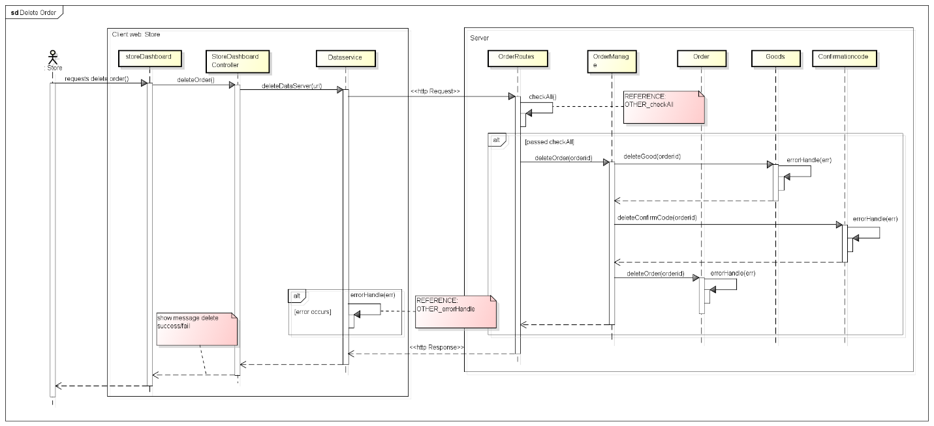***

###### 2.2.1.2.10. View Order’s Detail

***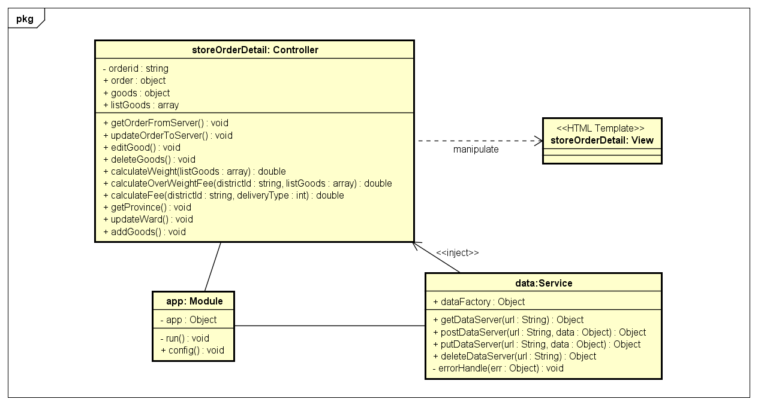***

***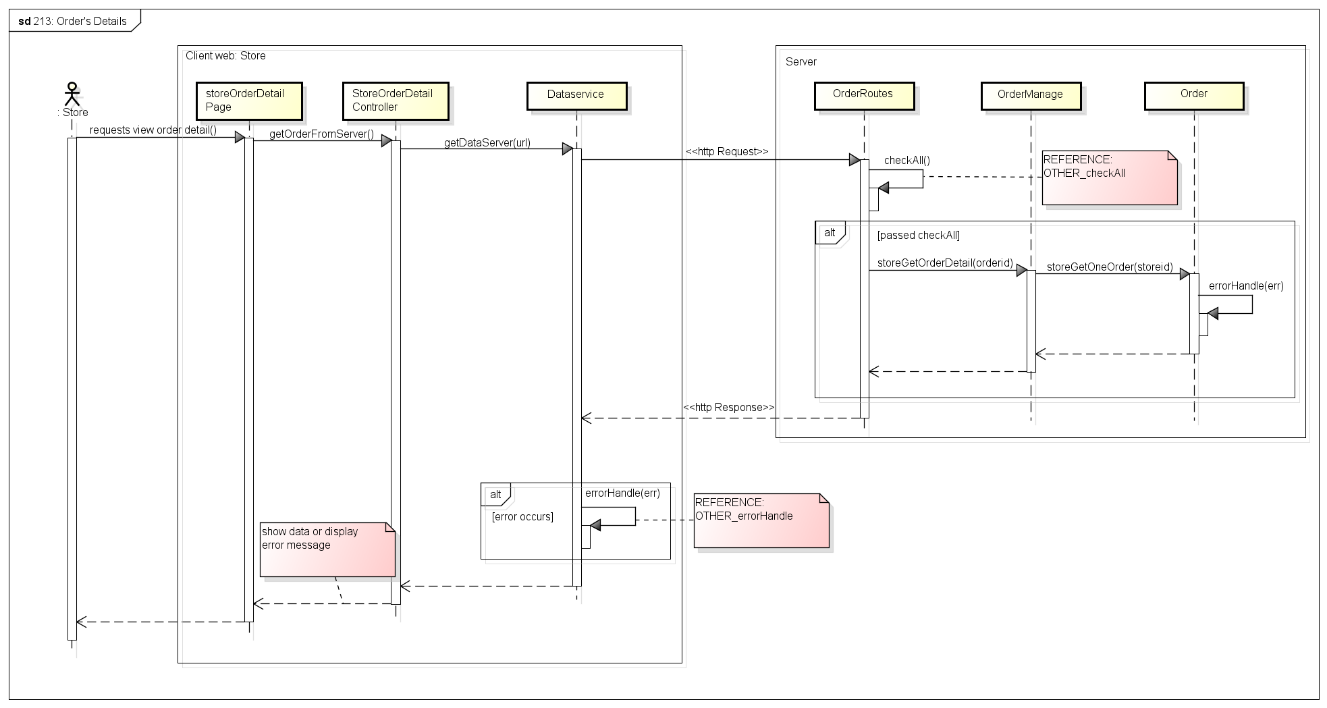***

###### 2.2.1.2.11. View Transaction History

***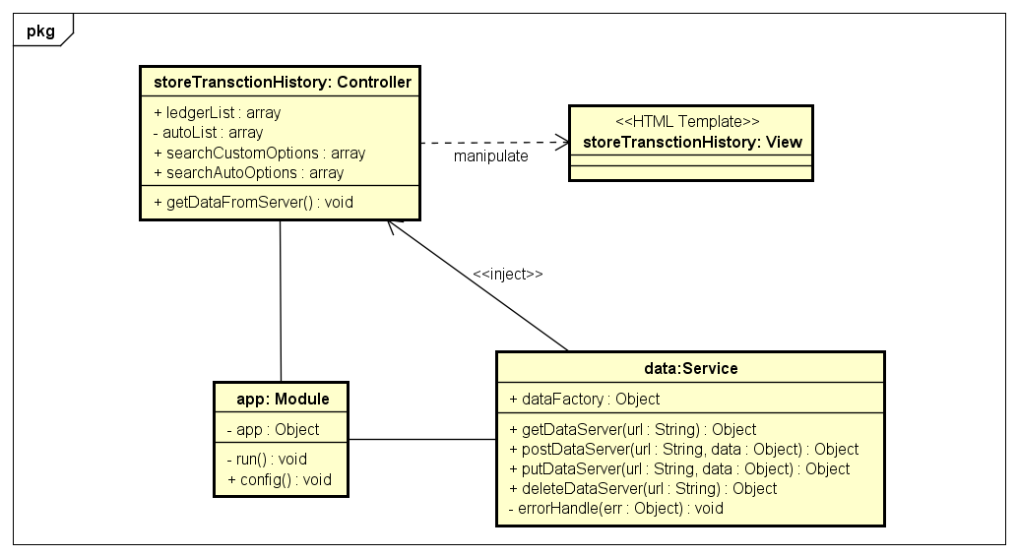***

***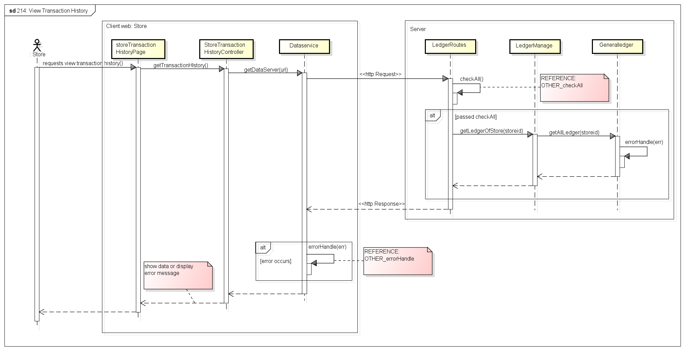***

##### **Common**

###### 2.2.1.3.1. Login

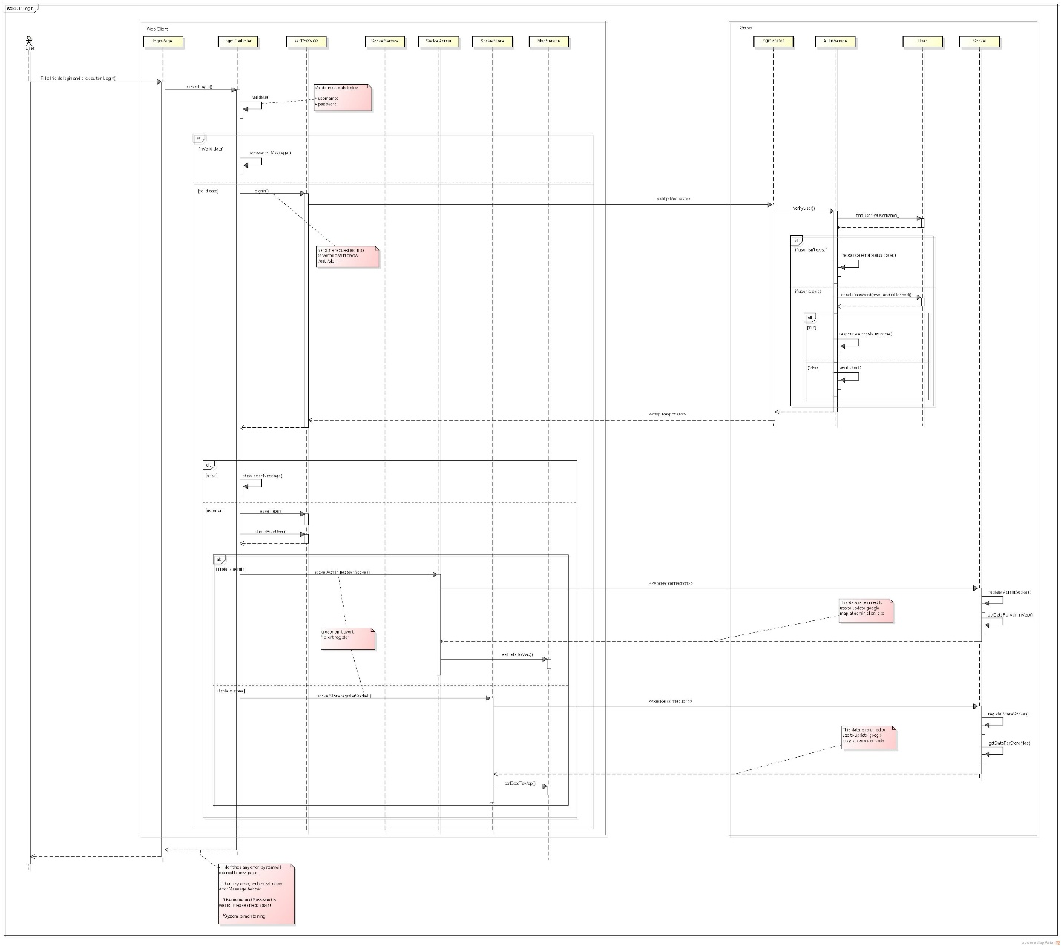

###### 2.2.1.3.2. Logout

***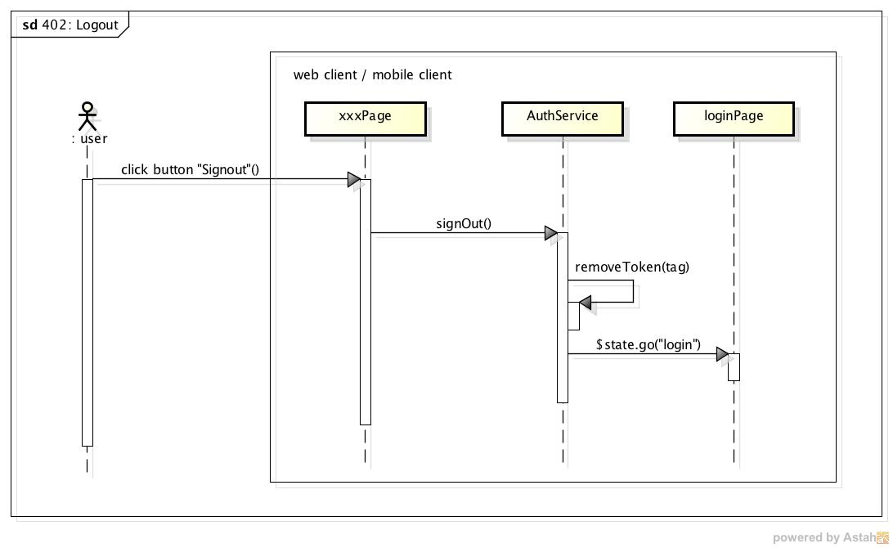***

###### 2.2.1.3.3. CheckAll

***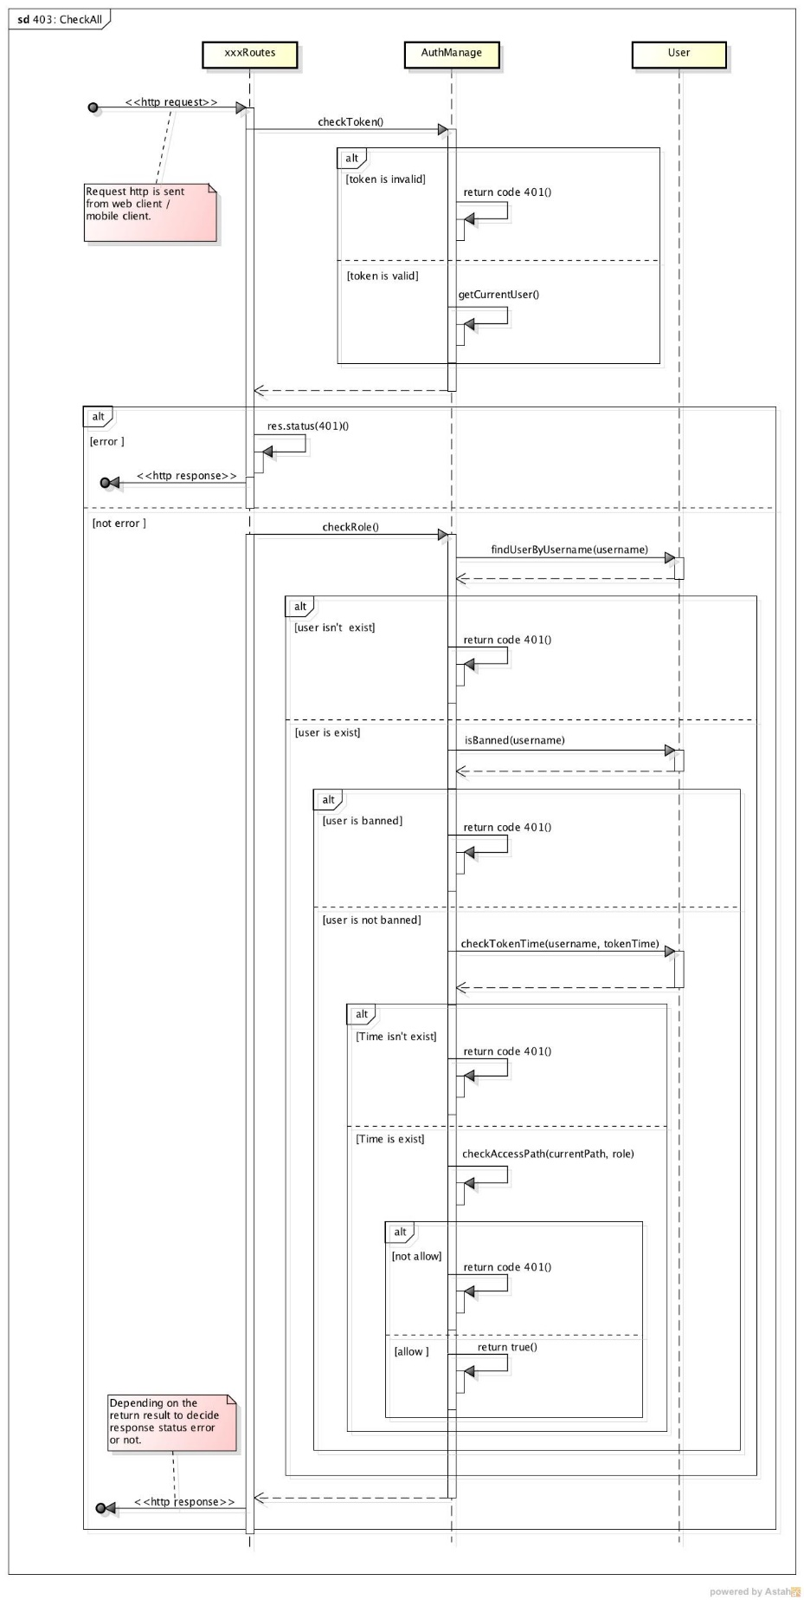***

###### 2.2.1.3.4. ErrorHandle

***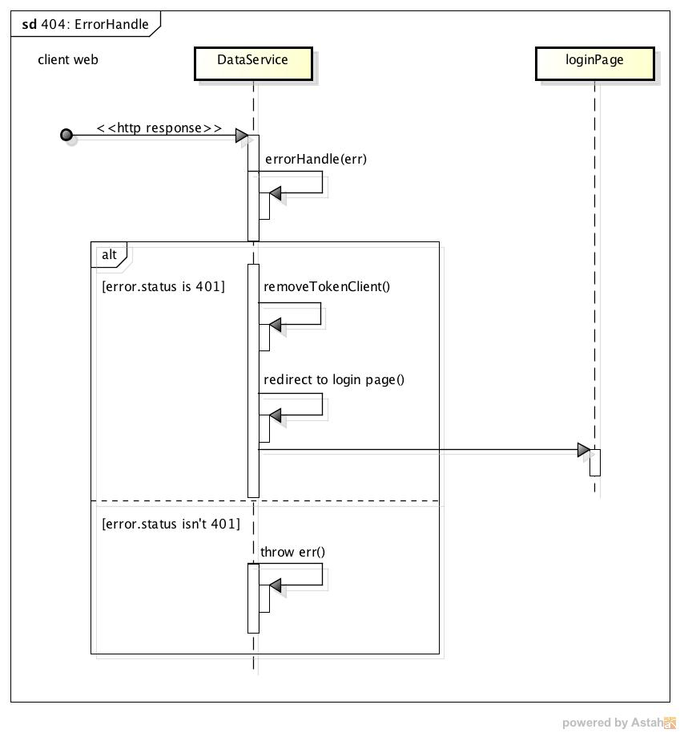***

###### 2.2.1.3.5. Notification

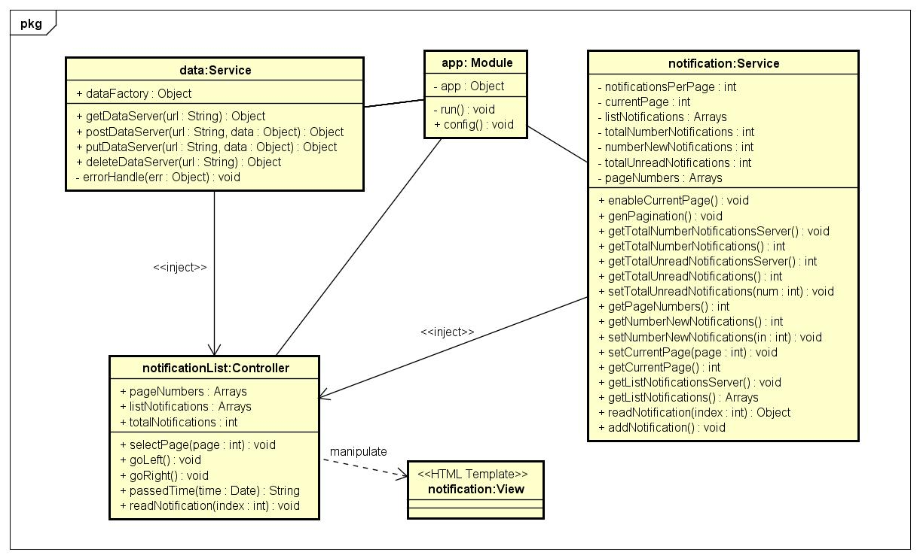

***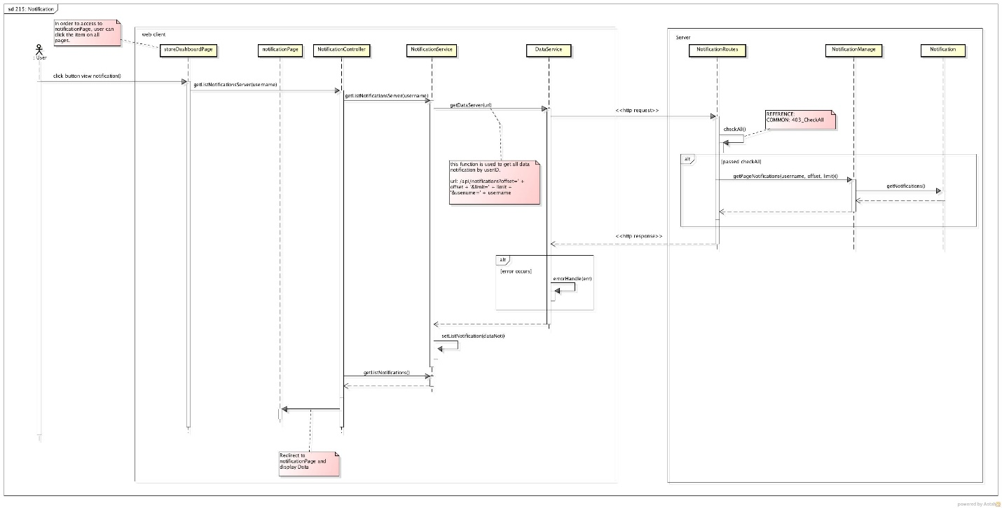***

##### **Class description**

###### AdminAddStoreController

* Attributes

|  |  |  |  |  |
| --- | --- | --- | --- | --- |
| No | Attributes | Type | Default | Description |
|  | newStore | Object | N/A | Information of new Store |
|  | newStoreOwner | Object | N/A | Information of new Store Owner |

* Methods

|  |  |  |  |  |
| --- | --- | --- | --- | --- |
| No | Methods | Parameters | Return | Description |
| 1 | getDataFromServer | N/A | N/A | Get data from server to display to screen |
| 2 | createStore | N/A | N/A | Post adding store request to server |

###### AdminAssignTaskController

* Attributes

|  |  |  |  |  |
| --- | --- | --- | --- | --- |
| No | Attributes | Type | Default | Description |
| 1 | tasksList | Array | [] | All tasks that can be assigned for other shipper of selected shipper |
| 2 | shipperList | Array | [] | List of all shipper |
| 3 | orderList | Array | [] | List of all orders that can be assigned for shipper |
| 4 | oldTasks | Array | [] | List tasks of shipper before assign |
| 5 | pickedShipper | Object | Null | Shipper is selected |
| 6 | searchShipperOptions | Array | [] | Options in drop-downlist for search shipper |

* Methods

|  |  |  |  |  |
| --- | --- | --- | --- | --- |
| No | Methods | Parameters | Return | Description |
| 1 | getDataFromServer | N/A | N/A | Get data from server to display to screen |
| 2 | assignTask | N/A | N/A | Send update shipper task request to server |
| 3 | pickOrder | Object | N/A | If user pick an order of order table, order will move to task table |
| 4 | pickTask | Object | N/A | If user pick an order of task table, order will move to order table |
| 5 | pickShipper | Object | N/A | After user select shipper, all tasks that can assigned for other shipper will be displayed in task table |
| 6 | moveAllProcessingTask | String | N/A | Move all orders in task table to order table |
| 7 | moveAllOrderToShipper | String | N/A | Move all orders which get issue to task table |
| 8 | sendSocketToShipper | N/A | N/A | Send a notification that task is assigned to shipper by socket |

###### AdminDashboardController

* Attributes

|  |  |  |  |  |
| --- | --- | --- | --- | --- |
| No | Attributes | Type | Default | Description |
| 1 | onlineShipper | Int | 0 | Number of online shippers |
| 2 | inactiveList | Array | [] | List of inactive tasks |
| 3 | activeList | Array | [] | List of active tasks |
| 4 | doneList | Array | [] | List of done tasks |
| 5 | failList | Array | [] | List of fail tasks |
| 6 | totalTaskToday | Int | 0 | Number of tasks in today |
| 7 | totalDoneToday | Int | 0 | Number of tasks have been done today |
| 8 | totalShipper | Int | 0 | Number of total shipper in system |
| 9 | totalDelivery | Int | 0 | Total delivery cost today |
| 10 | totalCoD | Int | 0 | Total cash of delivery today |

* Methods

|  |  |  |  |  |
| --- | --- | --- | --- | --- |
| No | Methods | Parameters | Return | Description |
| 1 | getDataFromServer | N/A | N/A | Get data from server to display to screen |
| 2 | dateCompare | N/A | N/A | Compare date of task for sorting |

###### IssueBoxController

* Attributes

|  |  |  |  |  |
| --- | --- | --- | --- | --- |
| No | Attributes | Type | Default | Description |
| 1 | issueList | Array | [] | List of all issues |
| 2 | pageSize | Int | 1 | Total page of issue when display in list |
| 3 | currentPage | Int | 1 | Current page of issue list |

* Methods

|  |  |  |  |  |
| --- | --- | --- | --- | --- |
| No | Methods | Parameters | Return | Description |
| 1 | getDataFromServer | N/A | N/A | Get data from server to display to screen |
| 2 | sortByDate | N/A | N/A | Sort issue list by date when issue is sent |

###### IssueContentController

* Attributes

|  |  |  |  |  |
| --- | --- | --- | --- | --- |
| No | Attributes | Type | Default | Description |
| 1 | issueid | Int | N/A | IssueID of issue |
| 2 | resolveType | Int | N/A | Type of resolving issue |
| 3 | issue | Object | N/A | Detail of this issue |

* Methods

|  |  |  |  |  |
| --- | --- | --- | --- | --- |
| No | Methods | Parameters | Return | Description |
| 1 | updateResolve | N/A | N/A | Send update issue request to database after processing in client |
| 2 | showConfirm | Int | N/A | Show confirm resolve popup |
| 3 | resolveIssue | N/A | N/A | Update issue is resolved by resolve type |
| 3 | resolveReturnIssue | N/A | N/A | Update order and task when order is returned to store |
| 4 | resolveStoreIssue | N/A | N/A | Update order and task when order is cancelled by store and shipper hasn’t been taken order |
| 5 | resolveContinueIssue | N/A | N/A | Update order and task when shipper can continue with issue order |
| 6 | resolveChangeShipperIssue | N/A | N/A | Update order and task when order is changed to other shipper |

###### AdminOrderListController

* Attributes

|  |  |  |  |  |
| --- | --- | --- | --- | --- |
| No | Attributes | Type | Default | Description |
| 1 | orderList | Array | [] | List of all orders |
| 2 | searchOptions | Array | [] | List of type for search order |
| 3 | dateOptions | Array | [] | List of date type for search order by complete date or pickup date |

* Methods

|  |  |  |  |  |
| --- | --- | --- | --- | --- |
| No | Methods | Parameters | Return | Description |
| 1 | getDataFromServer | N/A | N/A | Get data from server to display to screen |

###### AdminShipperListController

* Attributes

|  |  |  |  |  |
| --- | --- | --- | --- | --- |
| No | Attributes | Type | Default | Description |
| 1 | shipperList | Array | [] | List of all shippers |
| 2 | searchOptions | Array | [] | List of type for search shipper |

* Methods

|  |  |  |  |  |
| --- | --- | --- | --- | --- |
| No | Methods | Parameters | Return | Description |
| 1 | getDataFromServer | N/A | N/A | Get data from server to display to screen |
| 2 | getShipperOnline | N/A | N/A | Get status of shipper to display status of shipper is on or off |

###### AdminStoreDetail

* Attributes

|  |  |  |  |  |
| --- | --- | --- | --- | --- |
| No | Attributes | Type | Default | Description |
| 1 | storeid | String | N/A | storeID of store |
| 2 | store | Object | N/A | Detail of this store |

* Methods

|  |  |  |  |  |
| --- | --- | --- | --- | --- |
| No | Methods | Parameters | Return | Description |
| 1 | getDataFromServer | N/A | N/A | Get data from server to display to screen |
| 2 | updateStore | N/A | N/A | Send update store request to server after information is modified by user |

###### AdminStoreListController

* Attributes

|  |  |  |  |  |
| --- | --- | --- | --- | --- |
| No | Attributes | Type | Default | Description |
| 1 | storeList | Array | [] | List of all store in system with ledger information |
| 2 | searchOptions | Array | [] | Type of store search |
| 3 | payFee | Int | 0 | Amount of payment when user add new transaction |
| 4 | selectedStore | Object | Null | Store is selected |
| 5 | reason | String | Null | Reason why store is blocked or is unblocked |

* Methods

|  |  |  |  |  |
| --- | --- | --- | --- | --- |
| No | Methods | Parameters | Return | Description |
| 1 | getDataFromServer | N/A | N/A | Get data from server to display to screen |
| 2 | showConfirm | N/A | N/A | Show Confirm Payment popup for user to enter payment |
| 3 | showConfirmAgain | N/A | N/A | Show Confirm Payment Again popup |
| 4 | blockConfirm | N/A | N/A | Show confirm popup when user block or unblock user |
| 5 | blockStore | N/A | N/A | Send update block store request to server |
| 6 | postLedger | N/A | N/A | Send post new transaction request after user confirm a payment |
| 7 | showTransactionHistory | Object, Date | N/A | Show popup contains transaction history of selected Store in specific period |

###### AdminTaskListController

* Attributes

|  |  |  |  |  |
| --- | --- | --- | --- | --- |
| No | Attributes | Type | Default | Description |
| 1 | taskList | Array | [] | List of all tasks |
| 2 | searchOptions | Array | [] | List of type for search task |

* Methods

|  |  |  |  |  |
| --- | --- | --- | --- | --- |
| No | Methods | Parameters | Return | Description |
| 1 | getDataFromServer | N/A | N/A | Get data from server to display to screen |
| 2 | dateSort | N/A | N/A | Sort taskList by taskdate |

###### AdminTransactionHistoryController

* Attributes

|  |  |  |  |  |
| --- | --- | --- | --- | --- |
| No | Attributes | Type | Default | Description |
| 1 | ledgerList | Array | [] | List of all transactions was added by admin |
| 2 | searchCustomOptions | Array | [] | List of type for search custom transaction |
| 3 | autoList | Array | [] | List of all transactions was added automatically by sytem |
| 4 | searchAutoOptions | Array | [] | List of type for search auto transaction |

* Methods

|  |  |  |  |  |
| --- | --- | --- | --- | --- |
| No | Methods | Parameters | Return | Description |
| 1 | getDataFromServer | N/A | N/A | Get data from server to display to screen |
| 2 | dateSort | N/A | N/A | Sort ledgerList and autoList by paydate |

###### AdminUserDetail

* Attributes

|  |  |  |  |  |
| --- | --- | --- | --- | --- |
| No | Attributes | Type | Default | Description |
| 1 | username | String | N/A | username of user |
| 2 | user | Object | N/A | Detail of this user |

* Methods

|  |  |  |  |  |
| --- | --- | --- | --- | --- |
| No | Methods | Parameters | Return | Description |
| 1 | getDataFromServer | N/A | N/A | Get data from server to display to screen |
| 2 | updateUserInfo | N/A | N/A | Send update user request to server after information is modified by admin |

###### StoreDashboardController

* Attributes

|  |  |  |  |  |
| --- | --- | --- | --- | --- |
| No | Attributes | Type | Default | Description |
|  | totalOrder | Int | N/A | Total not yet paid orders |
|  | orderToday | Int | N/A | Total orders on today |
|  | totalCod | Double | N/A | Total cash on delivery of not yet paid orders |
|  | todayCod | Double | N/A | Total cash on delivery on today |
|  | totalFee | Double | N/A | Total ship fee of not yet paid orders |
|  | todayFee | Double | N/A | Total ship fee on today |
|  | listOrderInprocess | Array | N/A | List of in process orders |
|  | listOrderDone | Array | N/A | List of completed orders |
|  | listOrderDraft | Array | N/A | List of draft orders |
|  | searchOptionsInProcess | Array | N/A | List of value for search in process order |
|  | searchOptionsDone | Array | N/A | List of value for search done order |
|  | searchOptionsDraft | Array | N/A | List of value for search draft order |

* Methods

|  |  |  |  |  |
| --- | --- | --- | --- | --- |
| No | Methods | Parameters | Return | Description |
| 1 | getDataFromServer | N/A | N/A | Get data from server to display to screen |
| 2 | cancerOrder | N/A | N/A | Post request to cancel order of store to server and update screen |
| 3 | deleteDraffOrder | N/A | N/A | Post request to delete order of store to server and update screen |
| 4 | setCancelFee | Object | N/A | Calculate ship fee for order that store want to cancel |
| 5 | findShipperAgain | Object | N/A | Request to find a shipper |

###### StoreCreateOrderController

* Attributes

|  |  |  |  |  |
| --- | --- | --- | --- | --- |
| No | Attributes | Type | Default | Description |
| 1 | order | Object | N/A | Information of new store |
| 2 | listGoods | Array | [] | List of new goods |
| 3 | goods | Object | N/A | Information of new goods |

* Methods

|  |  |  |  |  |
| --- | --- | --- | --- | --- |
| No | Methods | Parameters | Return | Description |
| 1 | addGoods | N/A | N/A | Add a goods to order |
| 2 | editGoods | N/A | N/A | Edit information of a goods |
| 3 | deleteGoods | N/A | N/A | Delete a goods |
| 4 | postCompleteOrder | N/A | N/A | Post information of order to server to add to database |
| 5 | calculateWeight | Array | Double | Calculate total weight of goods on order |
| 6 | calculateOverWeightFee | String,Array | Double | Calculate over weight fee for order |
| 7 | calculateFee | String | N/A | Move all orders which get issue to task table |
| 8 | getProvince | N/A | N/A | Get list Province from server to fill to province drop down list |
| 9 | GenerateRandomCode | N/A | String | Generate code for authenticate shipper and end customer |
| 10 | updateWard() | N/A | N/A | Update ward drop down list when store change district. |

###### StoreOrderHistoryController

* Attributes

|  |  |  |  |  |
| --- | --- | --- | --- | --- |
| No | Attributes | Type | Default | Description |
| 1 | orderList | Array | N/A | List of order |
| 2 | searchOptions | Array | N/A | List value for search orders |

* Methods

|  |  |  |  |  |
| --- | --- | --- | --- | --- |
| No | Methods | Parameters | Return | Description |
| 1 | getDataFromServer | N/A | N/A | Get data from server to display to screen |

###### StoreProfileController

* Attributes

|  |  |  |  |  |
| --- | --- | --- | --- | --- |
| No | Attributes | Type | Default | Description |
| 1 | store | Object | N/A | Information of store |

* Methods

|  |  |  |  |  |
| --- | --- | --- | --- | --- |
| No | Methods | Parameters | Return | Description |
| 1 | getStoreProfile | N/A | N/A | Get data from server to display to screen |

###### OrderDetailController

* Attributes

|  |  |  |  |  |
| --- | --- | --- | --- | --- |
| No | Attributes | Type | Default | Description |
| 1 | orderid | String | N/A | Id of Order get from previous screen |
| 2 | order | Object | N/A | Information of order |
| 3 | goods | Object | N/A | Information of goods |
| 4 | listGoods | Array | N/A | List of |

* Methods

|  |  |  |  |  |
| --- | --- | --- | --- | --- |
| No | Methods | Parameters | Return | Description |
| 1 | getOrderFromServer | N/A | N/A | Get data from server and display to screen |
| 2 | updateOrderToServer | N/A | N/A | Post information of order to server to request update to database |
| 3 | editGoods | N/A | N/A | Edit information of a goods |
| 3 | addGoods | N/A | N/A | Add a goods to order |
| 4 | deleteGoods | N/A | N/A | Delete a goods |
| 5 | calculateWeight | Array | Double | Calculate total weight of goods on order |
| 6 | calculateOverWeightFee | String,Array | Double | Calculate over weight fee for order |
| 7 | calculateFee | String | N/A | Move all orders which get issue to task table |
| 8 | getProvince | N/A | N/A | Get list Province from server to fill to province drop down list |

###### StoreTransctionController

* Attributes

|  |  |  |  |  |
| --- | --- | --- | --- | --- |
| No | Attributes | Type | Default | Description |
| 1 | ledgerList | Array | [] | List of all transactions was added by admin |
| 2 | searchCustomOptions | Array | [] | List of type for search custom transaction |
| 3 | autoList | Array | [] | List of all transactions was added automatically by sytem |
| 4 | searchAutoOptions | Array | [] | List of type for search auto transaction |

* Methods

|  |  |  |  |  |
| --- | --- | --- | --- | --- |
| No | Methods | Parameters | Return | Description |
| 1 | getDataFromServer | N/A | N/A | Get data from server to display to screen |

###### LoginController

* Attributes

|  |  |  |  |  |
| --- | --- | --- | --- | --- |
| No | Attributes | Type | Default | Description |
| N/A | N/A | N/A | N/A | N/A |

* Methods

|  |  |  |  |  |
| --- | --- | --- | --- | --- |
| No | Methods | Parameters | Return | Description |
| 1 | Submit | Object | Object | This function is used to send a request submit form login into server. Then, server will response data back. |

###### Notification

* Attributes

|  |  |  |  |  |
| --- | --- | --- | --- | --- |
| **No** | **Attributes** | **Type** | **Default** | **Description** |
| 1 | pageNumbers | Array | [] | Array of index of page number for pagination |
| 2 | listNotifications | Array | [] | Array of notifications in a page |
| 3 | totalNotifications | int | 0 | Total number of notifications of a user |

* Methods

|  |  |  |  |  |
| --- | --- | --- | --- | --- |
| **No** | **Methods** | **Parameters** | **Return** | **Description** |
| 1 | selectPage | int | N/A | Change to a page and update displayed list of notifications |
| 2 | goLeft | N/A | N/A | Go to left page of current page in pagination. |
| 3 | goRight | N/A | N/A | Go to right page of current page in pagination |
| 4 | passedTime | Date | String | Convert created date of notification to amount of elapsed time from current moment |
| 5 | readNotification | int | Object | Request to server to update status isRead of notification |

###### NotificationService

* Attributes

|  |  |  |  |  |
| --- | --- | --- | --- | --- |
| **No** | **Attributes** | **Type** | **Default** | **Description** |
| 1 | notificationsPerPage | int | 7 | Constant for number of notifications per page in pagination |
| 2 | currentPage | int | 0 | Current selected page of notifications |
|  | listNotifications | Array | [] | Displayed list of notifications of current selected page |
|  | totalNumberNotifications | int | 0 | Total number of notifications of a user |
|  | numberNewNotifications | int | 0 | Total number of unread notifications of a user |
|  | totalUnreadNotifications | int | 0 | Total number of unread notifications of a user |
|  | pageNumbers | Array | [] | Array of index of page number for pagination |

* Methods

|  |  |  |  |  |
| --- | --- | --- | --- | --- |
| **No** | **Methods** | **Parameters** | **Return** | **Description** |
| 1 | genPagination | N/A | N/A | Generate array of page numbers (pageNumbers) for navigation in pagination based on notificationsPerPage and totalNumberNotifications |
| 2 | getTotalNumberNotificationsServer | N/A | Object | Request to server and return a promise to be resolved for total number of notifications of a user |
| 3 | getTotalUnreadNotificationsServer | N/A | int | Request to server and return a promise to be resolved for total number of unread notifications of a user |
| 4 | getPageNumbers | N/A | int | Return array of index of page number for pagination (pageNumbers) |
| 5 | getNumberNewNotifications | N/A | int | Return total number of unread notifications of a user (numberNewNotifications) |
| 6 | setNumberNewNotifications | int | N/A | Set value for total number of unread notifications of a user |
| 7 | setCurrentPage | int | N/A | Set value for current selected page |
| 8 | getCurrentPage | N/A | int | Return current index page |
| 9 | getListNotificationsServer | N/A | Array | Return list of notifications of current selected page |
| 10 | readNotification | int | Object | Request to server to update status isRead of a notification |
| 11 | addNotification | Object | Object | Request to server to add new notification and return a promise to be resolved for inserted notification |

###### AuthService

* Attributes

|  |  |  |  |  |
| --- | --- | --- | --- | --- |
| No | Attributes | Type | Default | Description |
| 1 | dataFactory | Object | {} | The object to provide API functions for calling from other places |

* Methods

|  |  |  |  |  |
| --- | --- | --- | --- | --- |
| No | Methods | Parameters | Return | Description |
| 1 | getDataServer | String | Object | Send http request to server with GET method |
| 2 | postDataServer | String, Object | Object | Send http request to server with POST method |
| 3 | putDataServer | String, Object | Object | Send http request to server with PUT method |
| 4 | deleteDataServer | String | Object | Send http request to server with DELETE method |
| 5 | errorHandle | Object | N/A | Handle the error return of sending http request, log out if the error has status 401 (Unauthorized) |

###### DataService

* Attributes

|  |  |  |  |  |
| --- | --- | --- | --- | --- |
| No | Attributes | Type | Default | Description |
| 1 | dataFactory | Object | {} | The object to provide API functions for calling from other places |

* Methods

|  |  |  |  |  |
| --- | --- | --- | --- | --- |
| No | Methods | Parameters | Return | Description |
| 1 | getDataServer | String | Object | Send http request to server with GET method |
| 2 | postDataServer | String, Object | Object | Send http request to server with POST method |
| 3 | putDataServer | String, Object | Object | Send http request to server with PUT method |
| 4 | deleteDataServer | String | Object | Send http request to server with DELETE method |
| 5 | errorHandle | Object | N/A | Handle the error return of sending http request, log out if the error has status 401 (Unauthorized) |

###### SocketService

* Attributes

|  |  |  |  |  |
| --- | --- | --- | --- | --- |
| No | Attributes | Type | Default | Description |
| 1 | socket | Object | N/A | Initial instance |
| 2 | api | Object | N/A | The public object to provide API functions |

* Methods

|  |  |  |  |  |
| --- | --- | --- | --- | --- |
| No | Methods | Parameters | Return | Description |
| 1 | on | String, function | N/A | Listen the specific event from socket server and then fire the callback function |
| 2 | sendPacket | Object,  Object,  Object,  String,  function | N/A | Send socket event to server and then fire the callback function |
| 3 | disconnect | N/A | N/A | Force disconnect a socket connection |
| 4 | connect | N/A | N/A | Setup a socket connection |

#### Web Server

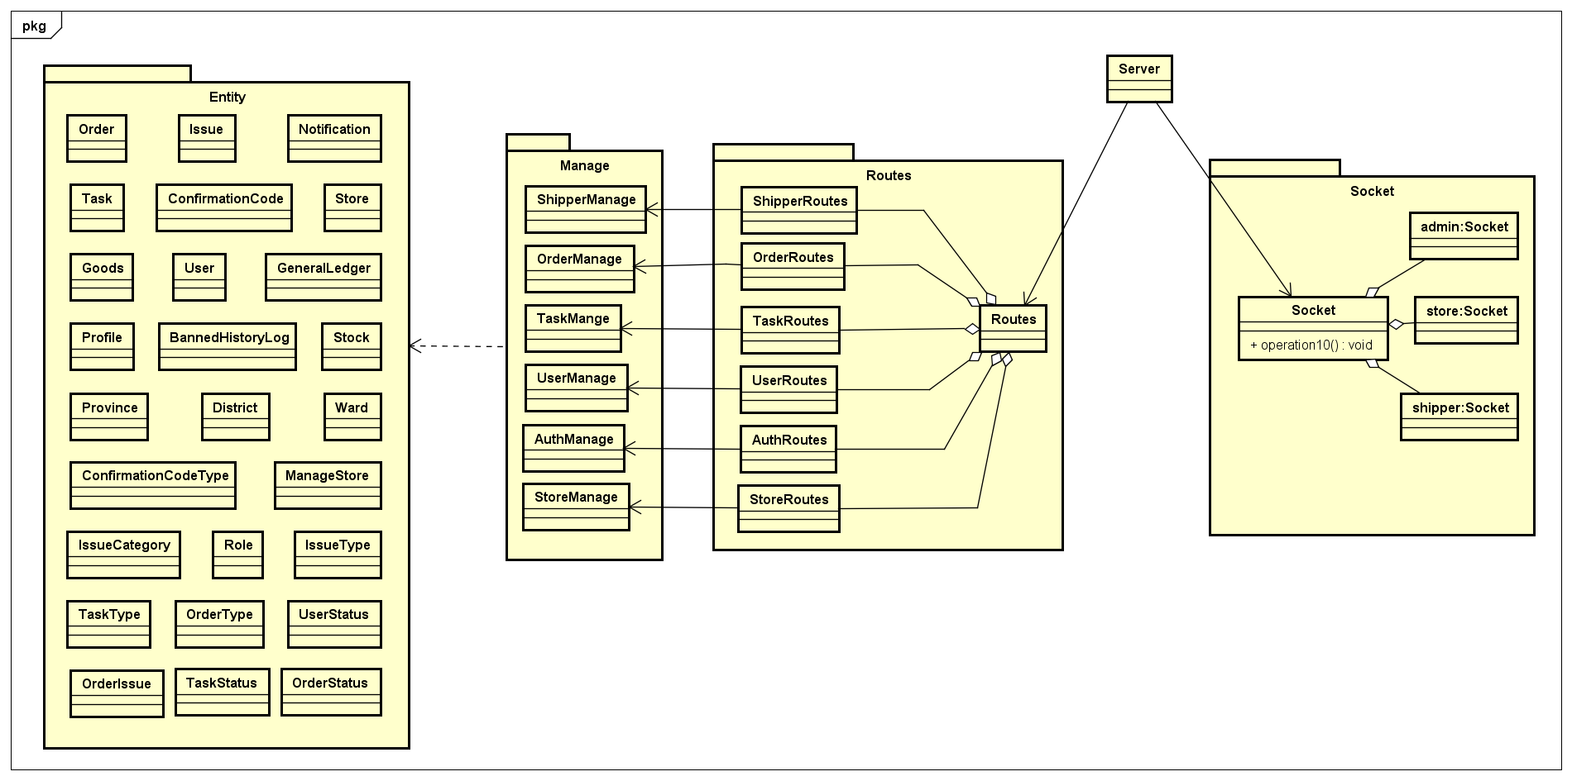

##### Class Description

###### 2.2.2.1.1. ShipperManage

* Attributes

|  |  |  |  |  |
| --- | --- | --- | --- | --- |
| No | Attributes | Type | Default | Description |
| N/A | N/A | N/A | N/A | N/A |

* Methods

|  |  |  |  |  |
| --- | --- | --- | --- | --- |
| No | Methods | Parameters | Return | Description |
| 1 | getTasks | String | Object | Return an object that hold info of all un-finished tasks regard to shipperID; throw error messages when get error |
| 2 | getHistory | String, int | Object | Return tasks done or fail regard to shipperID and current page to display |
| 3 | getDetail | String, int | Object | Return detail information of an task regard to shipperID and taskid |
| 4 | getOrderStatusList | N/A | Object | Return the object contents all the status of tasks |
| 5 | nextStep | N/A | String | Change the status of order to next step, change status of task; send socket notification to shipper and admin. Return a message success or error. |
| 6 | createIssuePending | String, Object, Array, int | Object | Create a new pending issue and add related order into database  Return the created issue |
| 7 | changeIsPending | String, int | N/A | Resolve an issue and send socket message to the store owns that order |
| 8 | getAllShipper | N/A | Array | Return list of all shippers |
| 9 | getAllOrderToAssignTask | N/A | Array | Return list of all orders that assignable in database |
| 10 | getAllShipperWithTask | N/A | Array | Return list of all shippers and their current tasks |
| 11 | getAllShipperWithTaskForProcessing | N/A | Array | Return list of shippers are having issue |
| 12 | updateTaskForShipper | Array | Object | Update information of a task |
| 13 | getShipperStatus | String | boolean | Get status of shipper by shipperID |
| 14 | getTaskBeIssuePending | String | Array | Get list of task is pending because the shipper got issue |
| 15 | countTaskOfShipper | String | int | Count current task of the shipper by shipperID |
| 16 | changeShipperStatus | String, boolean | String | Change status of shipper to on or off, return message success or error |
| 17 | createShipperID | N/A | String | Create an unique and valid ID for new shipper |

###### 2.2.2.1.2. IssueManage

* Attributes

|  |  |  |  |  |
| --- | --- | --- | --- | --- |
| No | Attributes | Type | Default | Description |
| N/A | N/A | N/A | N/A | N/A |

* Methods

|  |  |  |  |  |
| --- | --- | --- | --- | --- |
| No | Methods | Parameters | Return | Description |
| 1 | getAllIssue | N/A | Array | Get list of all issues in database |
| 2 | getIssueDetail | int | Object | Get detail information of an issue |
| 3 | updateResolveIssue | int, int | Object | Resolve an issue with type of resolve |
| 4 | postBannedLog | Object | Object | Ban a user cause of some reason |
| 5 | createIssueDisconnect | String | Object | Auto raise an issue when shipper disconnect away the socket server in period time |
| 6 | getUserHasIssue | N/A | Array | Get all users who are having un-resolved issue |

###### 2.2.2.1.3. UserManage

* Attributes

|  |  |  |  |  |
| --- | --- | --- | --- | --- |
| No | Attributes | Type | Default | Description |
| N/A | N/A | N/A | N/A | N/A |

* Methods

|  |  |  |  |  |
| --- | --- | --- | --- | --- |
| No | Methods | Parameters | Return | Description |
| 1 | getProfileUser | String | Object | Get profile of a user |
| 2 | getUserDetail | String | Object | Get detail information of a user |
| 3 | putUser | Object | Object | Update data of a user |
| 4 | putProfile | Object | Object | Update profile for a shipper |
| 5 | addNewUser | Object | Object | Create a new user |

###### 2.2.2.1.4. StoreManage

* Attributes

|  |  |  |  |  |
| --- | --- | --- | --- | --- |
| No | Attributes | Type | Default | Description |
| N/A | N/A | N/A | N/A | N/A |

* Methods

|  |  |  |  |  |
| --- | --- | --- | --- | --- |
| No | Methods | Parameters | Return | Description |
| 1 | get | N/A | Array | Get all stores |
| 2 | postNewStore | N/A | Object | Add new Store to database |
| 3 | put | N/A | Object | Update Store with new information to database |
| 4 | getLatestLedgerOfStore | String | Object | Get latest ledger information of specific store |
| 5 | getAllStoreWithLedger | N/A | Array | Get all stores with information of ledger |
| 6 | getTotalFee | N/A | Array | Get total fee of all stores |
| 7 | getTotalCoD | N/A | Array | Get total cash on delivery of all stores |
| 8 | getLatestAutoAccountDate | N/A | Date | Get latest date of ledger that is added automatically by system |
| 9 | updateLedgerForOrder | int | Object | Update which ledger is paid for order |
| 10 | postNewLedger | Object | Object | Add new ledger (transaction) to database |
| 11 | getStoreName | Array | Array | Get list store’s name by storeid |
| 12 | getStoreDetail | String | Object | Get detail of store by storeid |
| 13 | createStoreOwnerID | N/A | String | Create new username for new store owner |
| 14 | createStoreID | N/A | String | Create new storeid for new store |
| 15 | postNewManageStore | N/A | Object | Add relation of new store’s owner and new Store is managed by this store’s owner to database |
| 16 | getAllLedger | N/A | Array | Get all transaction |
| 17 | getLedgerOfStore | String, Date | Array | Get all ledgers of specific store after specific date |
| 18 | storeGetAllLedger | String | Object | Get all ledgers of specific store |

###### 2.2.2.1.5. OrderMange

* Attributes

|  |  |  |  |  |
| --- | --- | --- | --- | --- |
| No | Attributes | Type | Default | Description |
|  | wardID | String | N/A | ID of ward |
|  | name | String | N/A | Name of ward |
|  | type | String | N/A | Type of ward |
|  | districtID | String | N/A | ID of district has ward |
|  | location | String | N/A | Location of ward in map |

* Methods

|  |  |  |  |  |
| --- | --- | --- | --- | --- |
| No | Methods | Parameters | Return | Description |
| 1 | getAllOrder | String | Array | Get all order of store by storeID |
| 2 | calculateShipFee | String, Array, int | double | Calculate ship fee for an Order |
| 3 | calculateOverWeightFee | String, Array, Array | double | Calculate over weight fee for an Order |
| 4 | GenerateRandomCode | int | String | Create confirm codes for an Order |
| 5 | postOneOrder | Object | Object | Create new order into order table |
| 6 | updateOrder | Object | Object | Update order when user edit info of an order |
| 7 | deleteOrder | String | int | Delete an order in order table |
| 8 | putDraff | Object | Object | Add new draft order in order table |
| 9 | cancelOrder | Object | Object | Request cancel order from Store. Insert new row data into issue table, notification table and notify to Admin |
| 10 | getOrderList | Object | Array | Get all order list from order table |
| 11 | getTodayTotal | N/A | Array | Calculate total COD and Fee of all stores |
| 12 | storeGetOrderList | String | Array | Get list order of a store |
| 13 | countOrder | String | Array | Calculate total of order by month or year of a store. |
| 14 | getOverView | N/A | Array | Get all orders, stores, shipper, fee of system to statistical |
| 15 | pushIntoArray | Array, Object | int | Push Item into Array. If item not exist in array, then add item in array. If item exist in array, then update item.  Return index of item in array |
| 16 | getOrderCount | N/A | Array | Get number order of store by month, year |
| 17 | getMoneyCount | N/A | Array | Get total fee and cod of all orders of store |
| 18 | getCountOrdersDoneOrFail | N/A | Array | Count number of done orders and fail orders of all stores |
| 19 | getProvince | N/A | Array | Get all provinces |